CraigslistTM 101

About Craigslist:

Q: What is CraigslistTM?
A: Local classifieds and forums for more than 550 cities in over 50 countries worldwide - community moderated, and largely free.
Q: What can I find on Craigslist?
A: Jobs, housing, goods, services, romance, local activities, advice - just about anything really.
Q: How do I get to Craigslist?
A. Go to www.craiglist.org
Home page of Craigslist for Austin
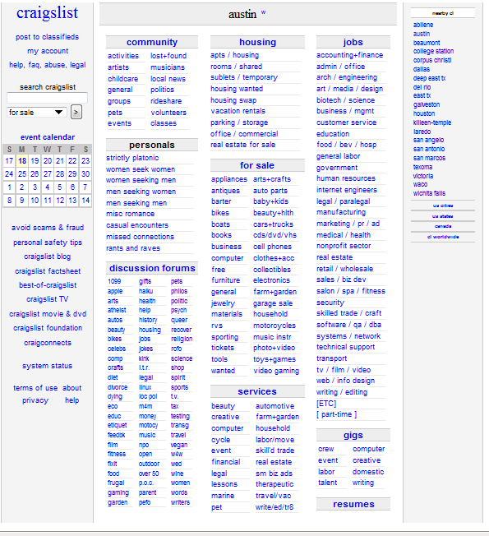

Craiglist User Accounts
Q. What is my craigslist user account? Do I need one?
A. No, you do not have to have an account, however…
You can manage posts efficiently with a craigslist user account. The process of creating posts, editing and deleting them, and re-posting ads that have expired is much easier.
If you post frequently, or if you need to post paid ads, it makes sense to set up a user account.
*Note: To place an ad in the “SERVICES” Category you MUST have an account
How do I create a user account?
- Go to the account signup form.
1. Enter your email address,
2. type the five-letter verification word that appears on the screen
3. Click "create account."

Account Signup Form
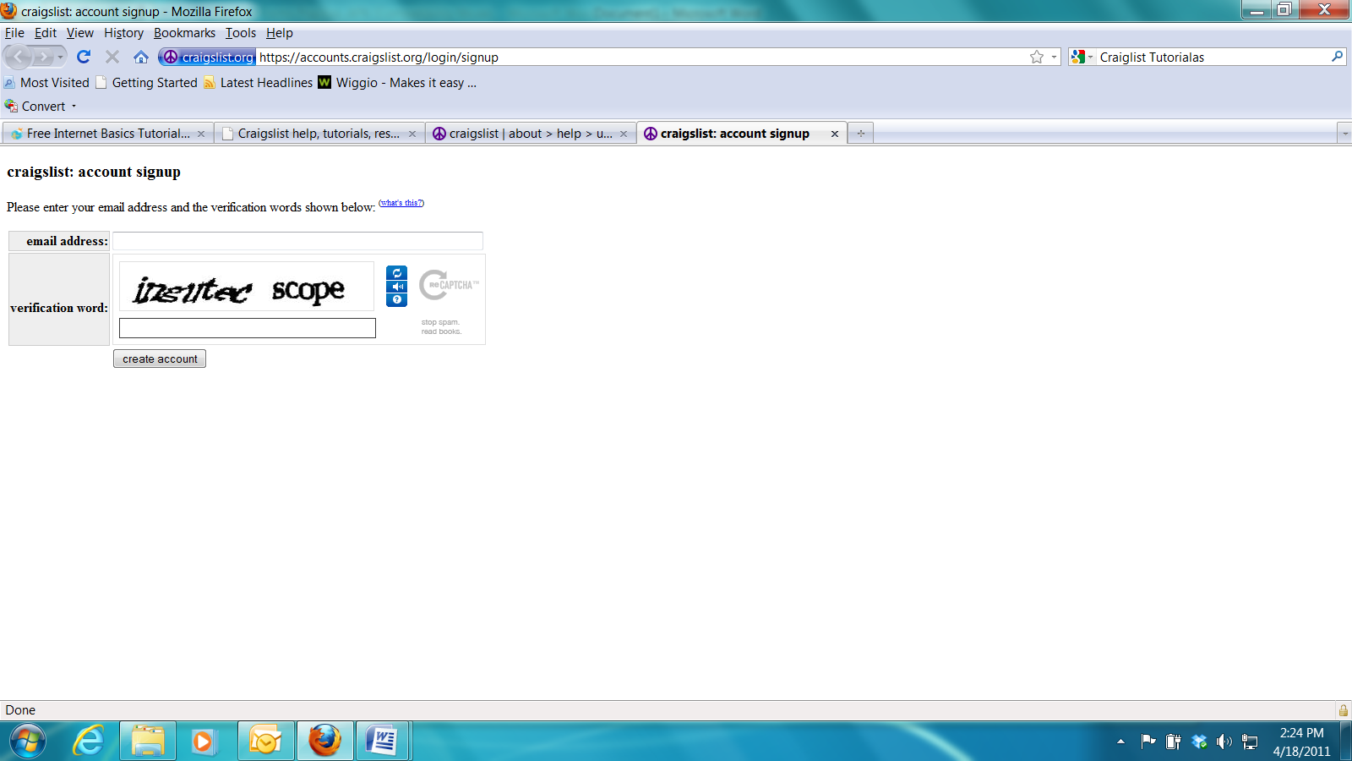
1.
2.
3.
4. Check your email for an email from: help@craigslist.org
Image of Craiglsit Email:
4
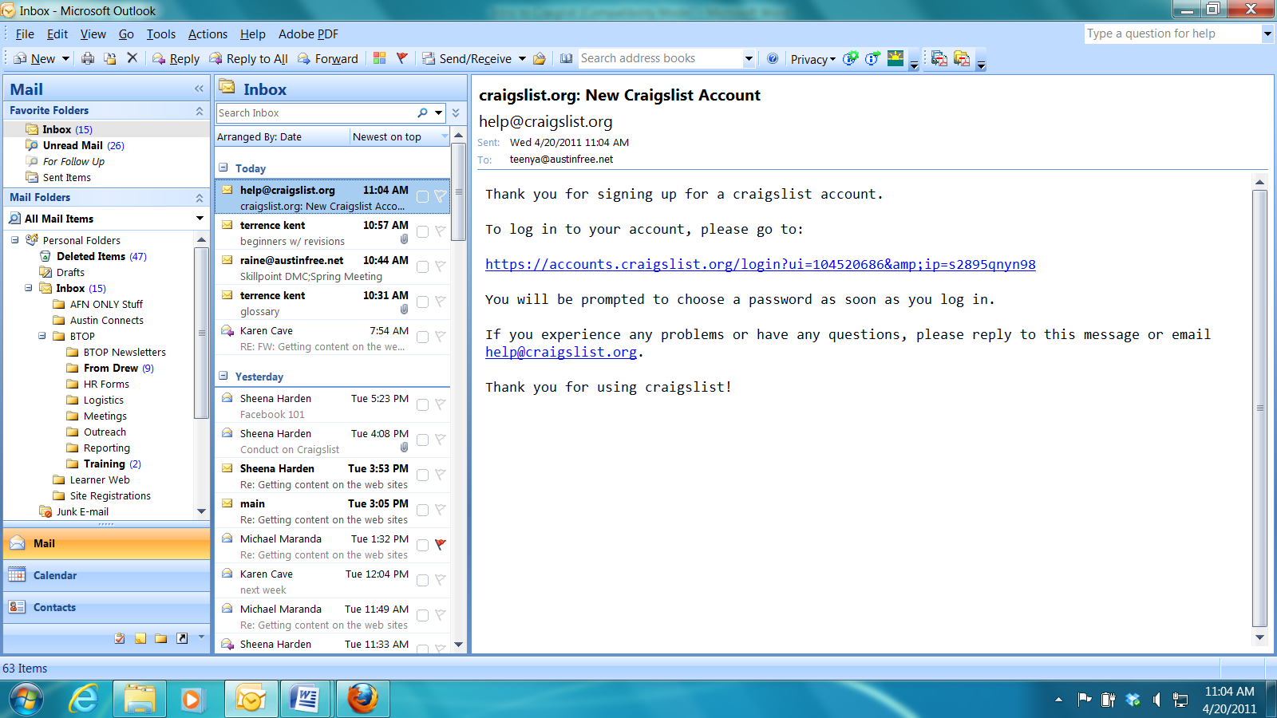
5
5. Click on the link in the email – this will open a browser window (internet page)

6. Select a password, type it in the first box and then retype it in the second box.
(IGNORE THE ERROR IN RED – this is an error on their site- not anything you have done.)
7. Once you have typed in your password twice hit the “Submit Password and Log in” button

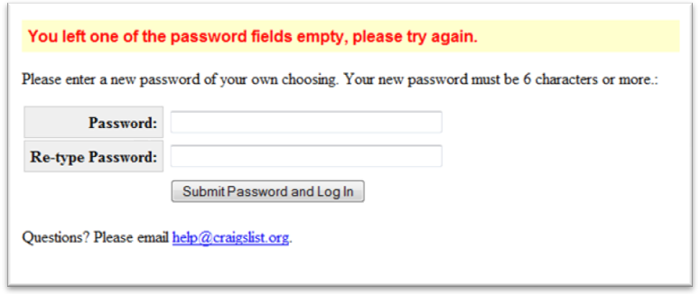
6
7
*NOTE: Passwords are case sensitive – make sure you type it EXACTLY the same way both times.
8. After you hit submit you will be taken to the “Terms of Use” screen below.
Read through it and then click the “I Accept” Button.
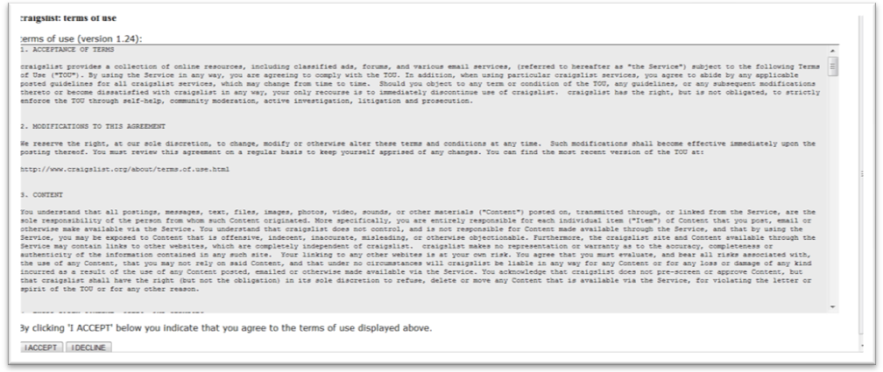
8
Congratulations ! You have now completed the process of setting up an account on Craiglsit!!

Once you hit the submit button you will be taken to your own personal Craiglist Home page

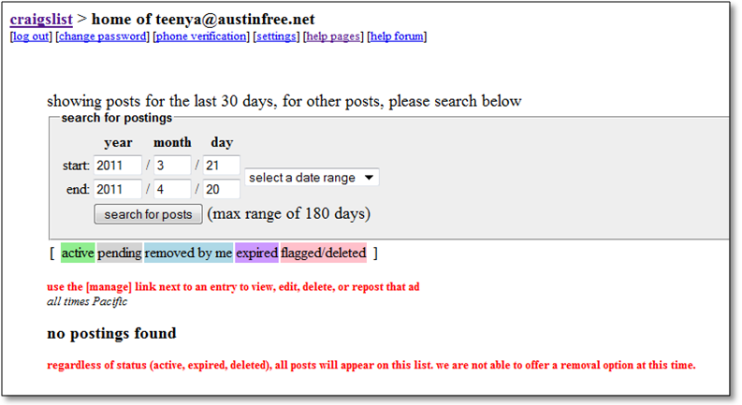

To return to the Main Home page of Criagslist Click the Craiglist link- or to Log Out- Click the Log Out link

To log in from the home page of Craigslist (www.craigslist.org):

1. Click on the “My Account” link – This will take you to the Account Log-In Page. (See next page)

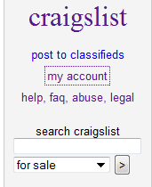
1

2. Enter the email address you used to create your account with
3. Enter the password you chose when you created your account.
4. Click the “Log-In” Button

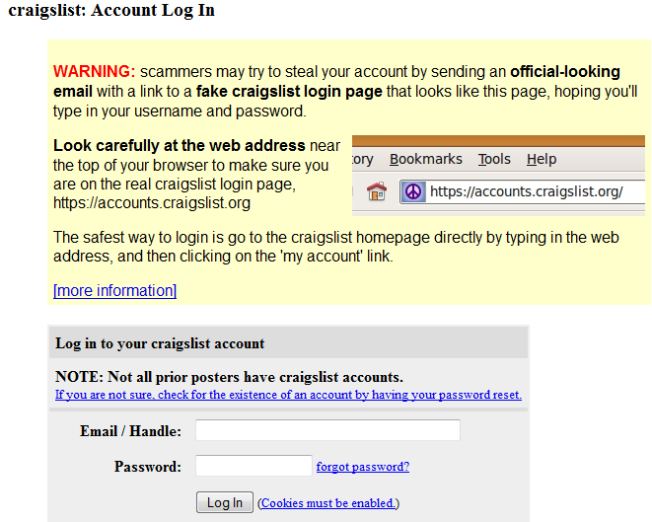
2
3
4

About Scams
You can sidestep would-be scammers by following these common-sense rules:
- Deal locally with folks you can meet in person- follow this one rule and avoid 99% of scam attempts on craigslist.
- Never wire funds via Western Union, Moneygram or any other wire service - anyone who asks you to do so is a scammer.
- Fake Cashier Checks & Money orders are Common and Banks will cash them and Hold YOU Responsible when the fake is discovered weeks later.
- Craigslist is not involved in any transaction and does not handle payments, guarantee transactions, provide escrow services, or offer "buyer protection" or "seller certification"
- Never give out financial information (bank account number, social security number, eBay/PayPal info, etc.)
- Avoid deals involving shipping or escrow services and know that only a scammer will guarantee your transaction.
- Do not rent housing without seeing the interior or purchase expensive items sight- in all likelihood that housing unit is not actually for rent and that cheap item does not exist.
- Do not submit to credit checks or background checks for a job or for housing until you have met the interviewer or landlord/ agent in person.

Recognizing scams
Most scams involve one or more of the following:
- inquiry from someone far away, often in another country
- Western Union, Money Gram, cashier's check, money order, shipping, escrow service, or a "guarantee"
- inability or refusal to meet face-to-face before consumating transaction

Examples of Scams
1. Someone claims that craigslist will guarantee a transaction, certify a buyer/seller, OR claims that craigslist will handle or provide protection for a payment.
- These claims are fraudulent, as craigslist does not have any role in any transaction.
- Scammer will often send an official looking email that appears to come from craigslist, offering a guarantee, certifying a seller, providing payment services -- all such emails are fakes!
2. Distant person offers a genuine-looking (but fake) cashier's check
- You receive an email (examples below) offering to buy your item, or rent your apartment, sight unseen.
- Cashier’s check is offered for your sale item, as a deposit for an apartment, or for your services.
- value of cashier's check often far exceeds your item - scammer offers to "trust" you, and asks you to wire the balance via money transfer service
- Banks will often cash these fake checks AND THEN HOLD YOU RESPONSIBLE WHEN THE CHECK FAILS TO CLEAR, including criminal prosecution in some cases!
- scam often involves a 3rd party (shipping agent, business associate owing buyer money, etc)
3. Someone requests wire service payment via Western Union or MoneyGram:
- Scam "bait" items include apartments, laptops, TVs, cell phones, tickets, and other high value items
- Often claim that an MTCN or confirmation code is needed before he can withdraw your money - this is FALSE, once you've wired money, it is GONE.
- Common countries currently include: Nigeria, Romania, United Kingdom, Ukraine, Spain, Italy, Netherlands - but could be anywhere
- Apartment listing may be local, but landlord/owner is "travelling" or "relocating" and needs you to wire money to them abroad
- Deal often seems too good to be true, price is too low, rent is below market, etc
4. Distant person offers to send you a money order and then have you wire money:
- this is ALWAYS a scam, in our experience - the cashier's check is FAKE
- sometimes accompanies an offer of merchandise, sometimes not
- scammer often asks for your name, address, etc for printing on the fake check
- deal often seems too good to be true
5. Distant seller suggests use of an online escrow service.
- most online escrow sites are FRAUDULENT, operated by scammers
- for more info, do a google search on "fake escrow" or "escrow fraud"
6. Distant seller asks for a partial payment upfront, after which he will ship goods
- he says he trusts you with the partial payment
- he may say he has already shipped the goods
- deal often sounds too good to be true
7. Foreign company offers you a job receiving payments from customers, then wiring funds
- foreign company may claim it is unable to receive payments from its customers directly
- you are typically offered a percentage of payments received
- this kind of "position" may be posted as a job, or offered to you via email

Actual scam emails sent to craigslist users:
First of all I want to thank you for your interest for my car. I sell it at this price ($2,980.00 ) because I have been divorced recently. Now the car is in my property and as a woman i don't need it. This car is in excellent working conditions, no scratches, flaws or any kind of damage, slightly used in 100% working and looking conditions and comes with a clear title.
From the beginning you have to know that for the payment I request only secure pay, I prefer the payment to be done using eBay services. We will use a safe payment method because I am affiliated at eBay and I have a purchase protection account for $20,000.00 The final price that I want for this car is $2,980.00 including shipping and handling. If you are interested in buying it please provide me your full name and address so I can initiate the deal through eBay.
I will wait your answer very soon.
Hello, I am looking for caring and honest person to watch my 3 years old daughter while I work, during our stay in the state and a friend introduced craiglist.com to me, I was searching on Childcare Babysitter, when your Ad post pumped up as a Childcare and Babysitter, am interested in your service as my babysitter/Childcare.. My Little daughters is (Mellina ) , I would like you to watch over her while i am at work in your Location , I reside in United Kingdom,I will be coming to the States in about two weeks time , Cos I just got a contract with Boss Perfume fashion industry down there, I work as a model and the contract will last for a month, the duration of our service wil be from 10am to 5pm, monday thru friday, I would like to know if she will be taken care of in your childcare centre/Home, or the hotel room where i would be lodging, It's Okay by me, any of this ways.
My little daughter (Mellina ) is 3 years old, I will be waiting patiently for your email indicating the cost of everything,I mean the price for your service,how long you will be available to take care of her,how much u charge per week. she is just three years old as i have said earlier and i will be glad to update you and make the payment in advance to show you how serious i am. So please get back to me as soon as you can if you will be able to handle her and take very good care of her for me.
Email me back
Your's faithfullyThanks for your mail,Since the cost of your bike is $800 i just contacted my client about the cost of your bike and it present condition and he said there is no problem about that. So my client said he will be issuing you a Certified Check of $4000 while you wire 3000 to me through Western Union Money Trasfer and you deduct the cost of your bike $800 and keep the remaining $200 which my client said you should take for the terms of Transaction and Agreement between you and my client. So i will like you to send me your full contact information to where my client will be sending you
the Certified Check like this:
name.........
full address.............
city...............
state.............
country..........
zipcode............
cell/office/home phone number.......................
I will look forward to the requested information as soon as possible so that the check can be sent out to you immediately And do get back to me with the Pics of the bike so that my client will be Able to see What he is paying off. Get back to me immediately. Looking towards your respond,
Best Regards.

Listings and Examples of well Known Craiglist Scams and Scammers:
http://www.snopes.com/
http://flakelist.org/

If you suspect that a craigslist post may be part of a scam, please send us the details through our online form at: http://sfbay.craigslist.org/cgi-bin/emailForm.cgi

Craigslist Contact Form
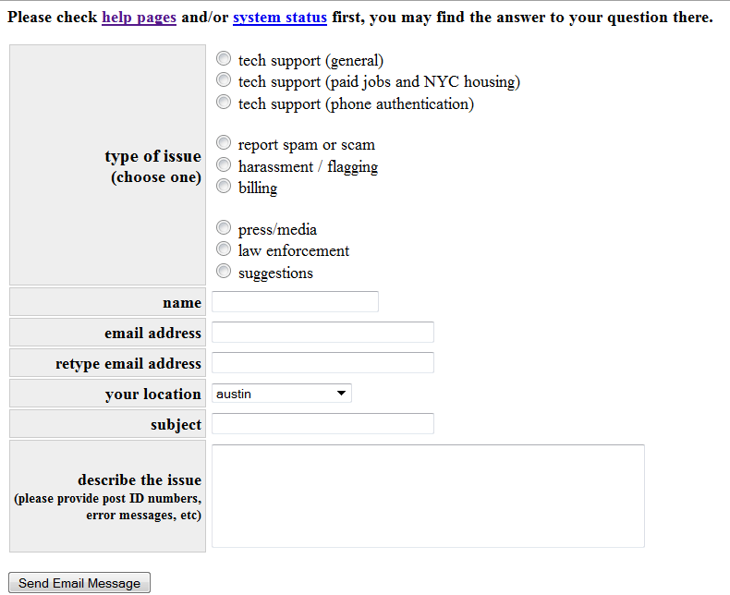

Who should I notify about fraud or scam attempts?
U.S. Federal
- Internet Fraud Complaint Center
- FTC Video: How to report scams to the FTC
- FTC online complaint form
- FTC toll free hotline: 877-FTC-HELP (877-382-4357)
- Consumer Sentinel/Military (for reports from services members or their families)
- SIIA Software and Content Piracy reporting
Canada
- Canadian Anti-Fraud Centre or 888-495-8501 (toll-free)
- RCMP
If you are defrauded by someone you met in person, contact your local police department.

Using the Search field:
To use the search feature, simply type in the key word(s) that you are looking for, select the heading or category and then click " > " or "search" if you are already in a category.
Example: You type the word "desk" and select the "for sale" area. Click the " > " to see the results.
The Search Field (left hand side of your screen)

If you want to narrow your search to a particular sub region click on a sub region from the right side of the home page
Sub Region Categories
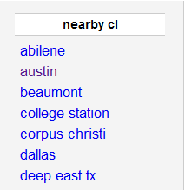

This will open up the Home Page for the Region you select- you can tell by the city name listed in the middle of the page

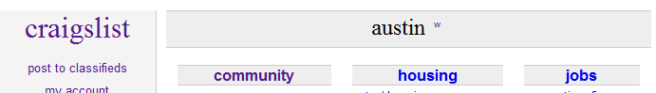

If you only want to search within a particular category, click on the category and use the search feature at the top right side of the page.

Craigslist Categories and Sub categories
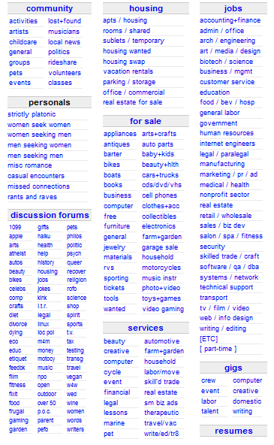
Circled items are the “Main Categories”.
Items underneath the Main Categories are “Sub-Categories”

Using the Category / Sub Category Search Form
3
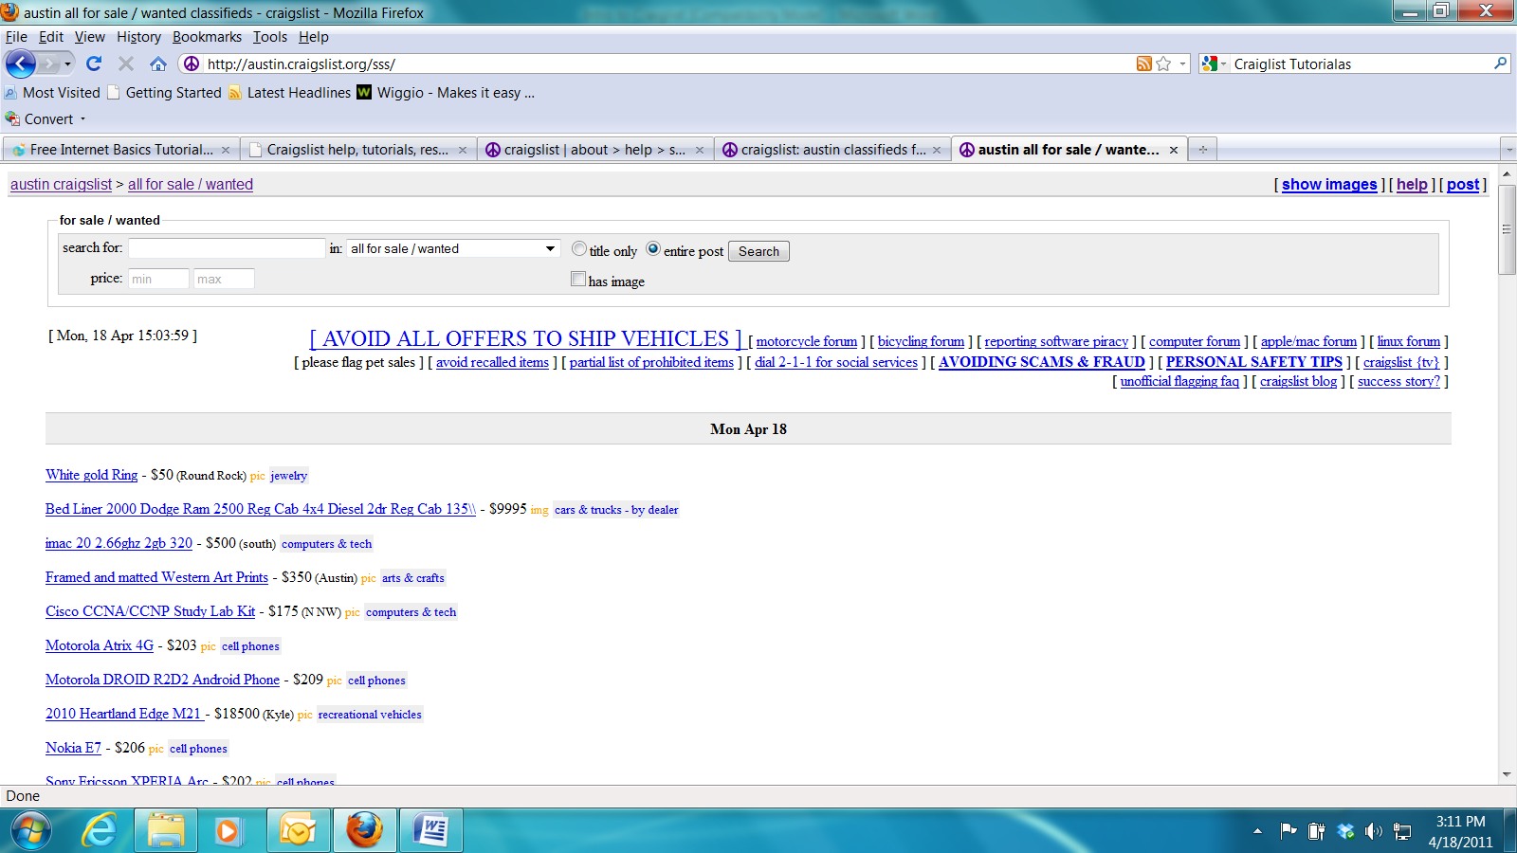
1
2
4
5
6
1. Fill in the name of the item you want to search for
2. Use the drop down arrow to select the category you want to search in
3. Pick to search for the item in Post Titles only or mention of the item within Posts
4. If you have a budget enter the minimum and maximum amounts you want to spend
5. If you want only items that have pictures available check the box “has image”
6. Click the “Search” Button

Search Tips:
Common words like "the" or "and" are removed from searches because they occur very frequently. If this happens, you will see a message at the top of the results telling you which words were ignored.
Advanced Searching
If simple keywords don't find what you are looking for, here are some advanced features to try.
Spelling
Make sure that you have spelled the name of the item correctly
Phrase Search
You can use quotation marks to search for a phrase:"low miles"
That will find posts that contain the term 'low' followed by 'miles'.
"OR" Searches
By default, every term in your search must match unless it is excluded with the minus sign (see above). You can specify a list of terms that you want to find one or more of (instead of ALL of them) using a "pipe" character '|' like this:
honda | toyota
That query looks for postings that contain 'honda' or 'toyota' (or both).
Posting ID
If someone has given you the Posting ID (10 digit number), you can use that number in the search box to find the posting.

Replying to a Post
To reply to a post via email:
Most posts display an email address in the upper left corner, below the title and date that is formatted in one of two ways:
A regular email address, such as janesmith@yahoo.com (replies are sent directly to the poster's email address)
An anonymous craigslist email address, such as sale-abcde-1234567890@craigslist.org (replies are forwarded by craigslist to the poster's actual email address)
To reply, you can either:
Highlight the “reply to:” address, then with the mouse pointer directly over the blue highlighted text click the right mouse button and select “copy”. You can now paste this address into your email “to” box.
For posts in the personals you will see a "Reply to This Post" button. To see the addresses to reply to the post, click on this and fill out the captcha.
Example of Captcha
Note: When you reply to a post, your email address will be visible to the recipient. If you prefer to remain anonymous, consider using an email address that does not contain your name or other identifying information. (Many users set up web-based email accounts through providers like Yahoo! or Gmail for this purpose.)
Alternative contact methods:
If the poster does not wish to be contacted via email, you may see "Reply to: see below" in place of an email address.
Look for a phone number, fax number, website address, or street address in the body of the posting.
If the post does not contain any contact info, you can notify the poster by clicking the "send note" button at the bottom of the post.
Troubleshooting Tips:
If you get an error message when you click on the highlighted email address, or if you do not recognize the email program that opens when you click that link, simply cut-and-paste the email address into a new message in your usual email application.
If your reply comes back to you with an "undeliverable" message, please check the following:
Is the ad still posted on the site? The anonymous craigslist email address will forward email messages to the poster only while the ad is active; once an ad is removed from the listings, reply will bounce back.)
Did you spell the email address correctly? (Common typos include omitting the hyphens, jobxxxxxxxxxx instead of job-xxxxx-xxxxxxxxxx, or forgetting the 's' after craig and entering craiglist.org instead of craigslist.org.) Copy and pasting email addresses helps prevent this kind of error.
Did you include a large file or image in your reply? (Attachments sent to a craigslist email address cannot exceed 7 megabytes.)
About this document: Materials adapted from parts of CraigslistTM Help: http://www.craigslist.org/about/help/

