Posting Ads to Craiglist
Q. Are all Ads Free?

A. All craigslist postings (also called “Ads”) are free, except for:
1. Job posts in the following states: San Francisco Bay Area, Atlanta, Austin, Boston, Chicago, Dallas, Denver, Houston, Los Angeles, New York, Orange County, Philadelphia, Phoenix, Portland, Sacramento, San Diego, Seattle, South Florida, and Washington DC.
2. Brokered apartment rental listings in New York
4. Posts in therapeutic services on craigslist sites in the United States.

There are two options for purchasing paid posts:
- post ads individually and pay by credit card for each ad
- buy a block of ads and pay for the block with a check

What kinds of postings are prohibited?

Conduct on Craigslist Simplified

DO NOT post, email or link
- Anything against the law or that shows or describes unlawful acts; anything harmful, that speaks badly of another person, is abusive, threatening, invasive of someone’s privacy, or harmful to minors
- Anything pornographic or sexual, including nudity
- Hate speech in any form; nothing that harasses, degrades, intimidates or is hateful toward any person or group on the basis of religion, gender, sexual orientation, race, ethnicity, age, or disability
- Anything that violates the Fair Housing Act, meaning a notice or advertisement for the sale or rental of property that discriminates or indicates preference based on race, color, national origin, religion, gender, age or disability
- Anything that violates equal employment opportunity laws, meaning a job posting, advertisement or listing that discriminates or indicates preference based on race, color, national origin, residency status religion, gender, age or disability
- False information including impersonation of a person or entity, falsely claiming to represent or have affiliation with a person or organization; misleading, deceptive or incorrect information
- Anything about another person without that person’s explicit consent
- Anything that infringes on the proprietary rights of a party such as copyright, trademark, trade secret etc.
- Anything that contains unsolicited advertisement such as junk mail, spam, chain letters, pyramid schemes and the like
- Any illegal service or the sale of forbidden or restricted items a list is published on craigslist: http://craigslist.org/about/prohibited.items.html
- Advertisements, solicitations, links to commercial websites EXCEPT where allowed in the “services” section
DO NOT contact any craigslist user that has not indicated in writing that it is ok to contact them about other services, products or commercial interests

EVEN SIMPLER:
- Don’t be mean, hateful or discriminatory
- No porn
- No schemes or lies
- No commercials
- Nothing illegal
(Bullet points taken from Craigslist Terms of Use: http://www.craigslist.org/about/terms.of.use)

How do I post a free posting from my account?
Logging in to your account from the home page of Craigslist (www.craigslist.org):
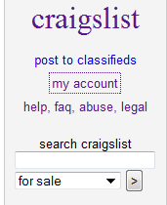
1
- Click on the “My Account” link – This will take you to the Account Log-In Page.
(See next page)

2. Enter the email address you used to create your account with
3. Enter the password you chose when you created your account.
4. Click the “Log-In” Button
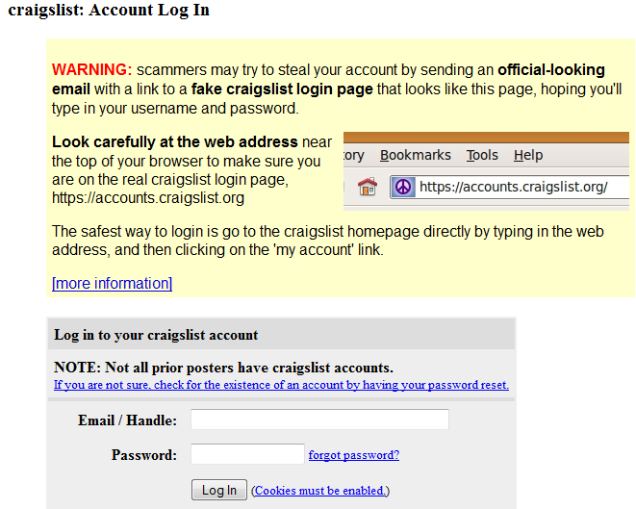
2
3
4

Once you hit “Log-In” you will be taken to your own personal Craiglist Home page.

5. To return to the Home page of Craiglist click the “craigslist” link.
5
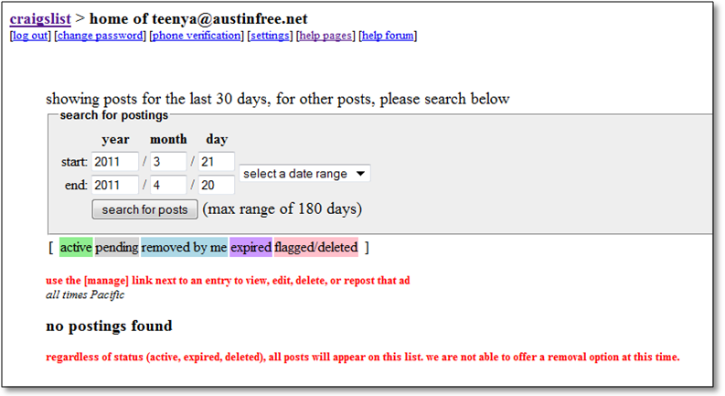
Once you are on the home page of Craigslist click “Post to Classifieds” It's located on the left-hand side of the page in the shaded area.
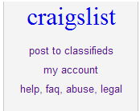
Creating your post:
- Select the Type of ad you want to post. For this class we will be selecting “service offered”
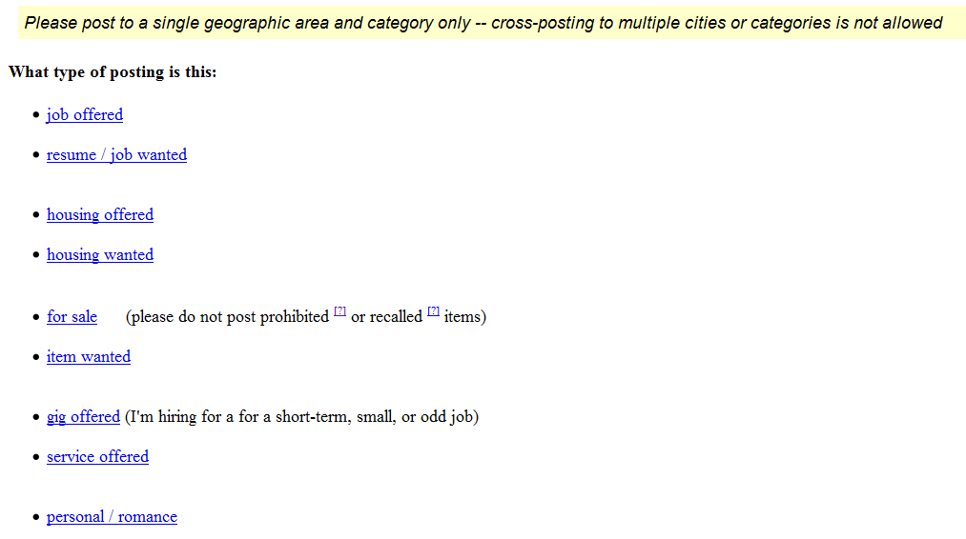
1
- Select the Category you want to post under. (we are going to select “household services”)
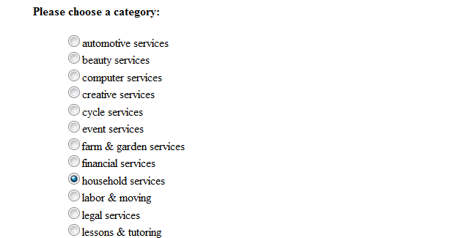
2
Once you have the selected “household services” click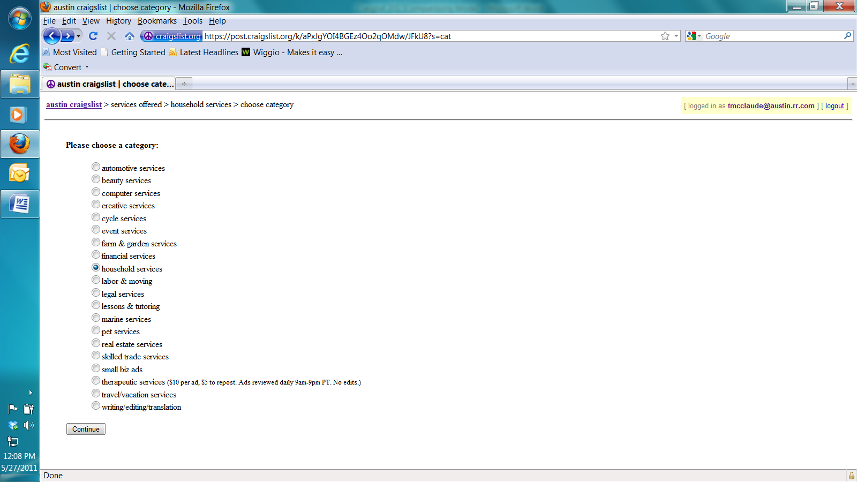, this will bring up a posting form.
Filling out the Posting form:
1. Create a title for your posting – the title should represent what type of service you are advertising.
2. Enter the location where you would like to offer your services (for example – what city, or part of town you would like to work in)
3. Under the “Reply-To:” section - Make sure that you select “anonymize”, you will still be able to receive replies to your posting, but your email address with remain confidential.
4. Enter a description for your post- the description should explain in detail the kinds services you are offering, perhaps the number of years you have been doing these services, the times and days you are available and anything else that you want potential readers of your post to know.
5. If you want others to be able to contact you about other services, products or commercial interest check the box at the bottom of the form.
6. Once you have completed the form click the “Continue” button.
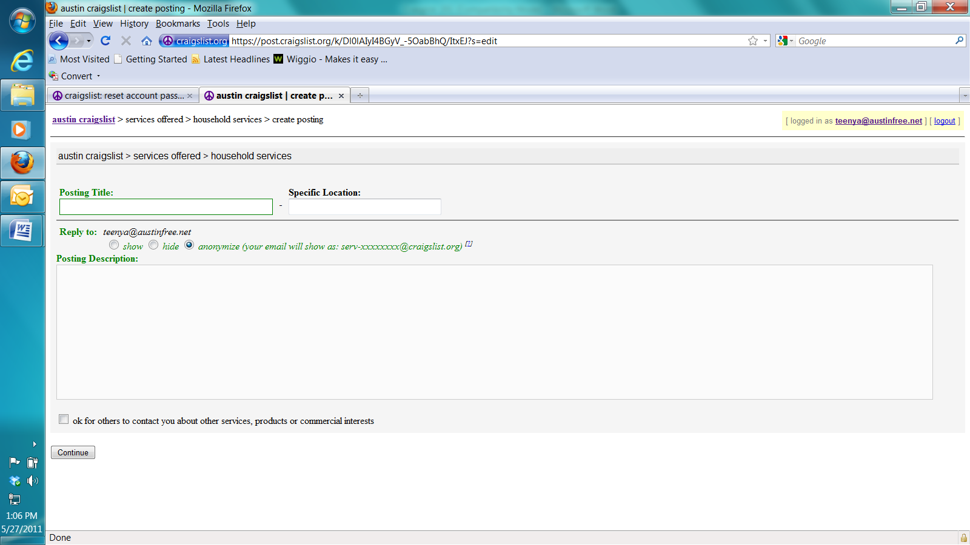
1.
2.
3.
4...
5
6
Use this area to enter your posting description
7. Once you hit Continue a screen with your post will come up. Review your posting for errors BEFORE you publish your post.
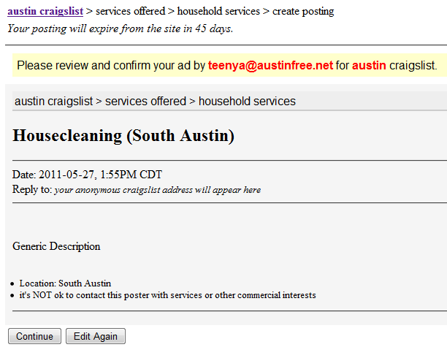
7

If the post is correct and does not need changes click on the “continue” button.

If the post needs changes click on the “Edit again” button – this will take you back to the posting form.

After clicking the continue button you may be prompted to enter Phone Verification information:
About Phone Verification:
Phone verification is sometimes required for posting on craigslist.
How does phone verification work?
You will be prompted to enter your phone number. Shortly after, you will receive an automated phone call or text message (SMS) that contains an authorization code. Enter this code on the next page of the process, and your account will be verified.
What if I type my phone number incorrectly?
If you enter the wrong phone number, press "try again" after five minutes and enter the correct number.
Please note:
- You may only try to call a phone number once every five minutes.
- You may only enter the code five times.
- You may only try three phone numbers per account every twelve hours.
- You may only receive three calls per account every twelve hours.
Disallowed numbers:
Some phone numbers are not usable for phone verification, including the following:
- Phone numbers from outside the U.S. or Canada
- Toll-free numbers (area codes 800, 877)
- Some Voice over IP (VOIP) phone numbers (including Cricket, MetroPCS)
What if my phone number is "already in use"?
If you receive an error message that your phone number is already in use, it means that the number you are trying to use for verification is already associated with another craigslist account. Account holders may unlink phone numbers from existing accounts in good standing 90 days after verification.
Phone Verification form
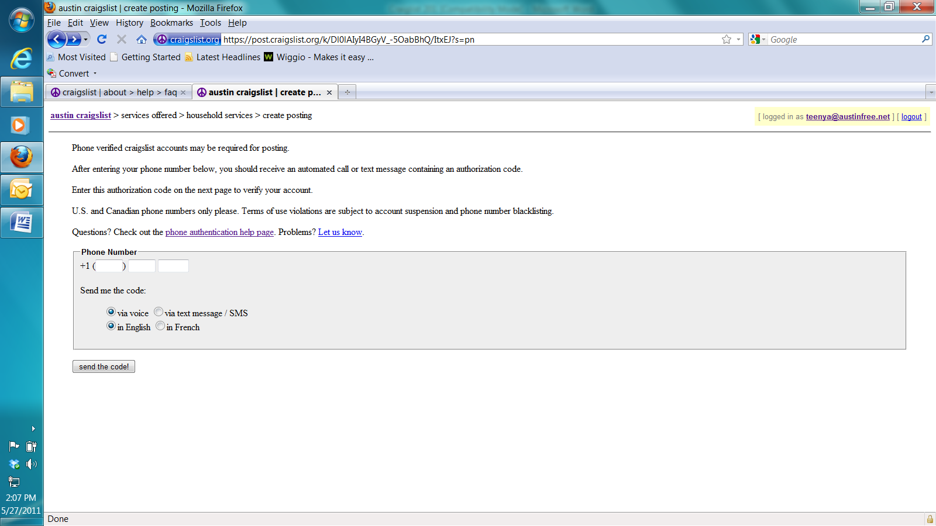
8
8. Enter your phone number and selected the way in which you wish to receive the code click:
A screen similar to the following should appear:
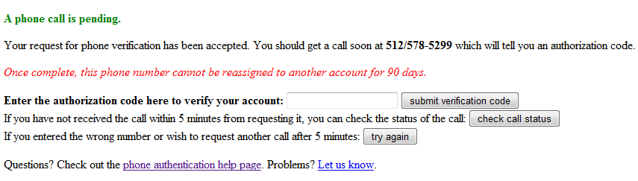
9
You should receive your code within a few minutes of submitting the phone number.
9. Once you receive your code enter it in the box and click “submit verification code”
10. A Captcha screen like this one will appear – enter the words/letters you see EXACTLY how they are on the screen and click “Continue”.
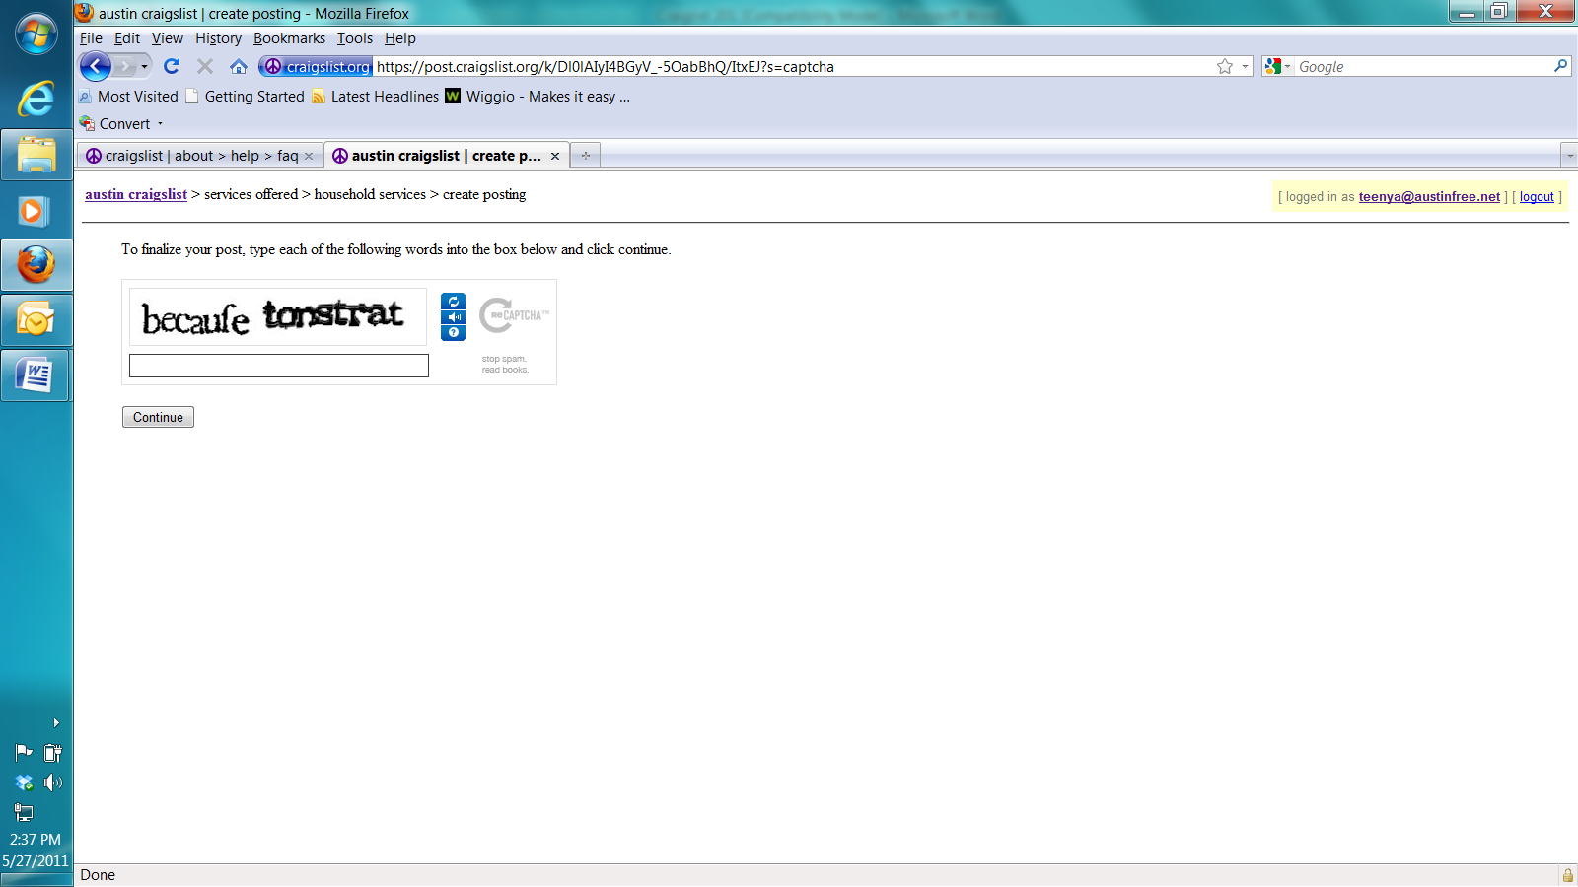
10
A screen like this one will appear with information about your posting:
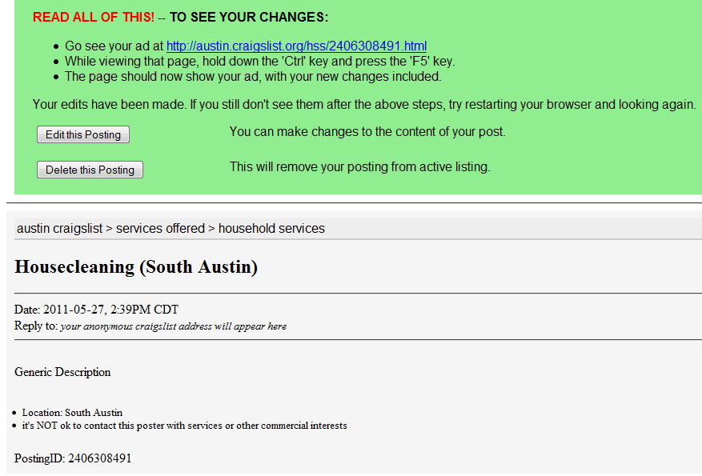
- You’ll receive an email containing a link to an online form.
- This form will allow you make last-minute changes and then self-publish your posting.
- Once published, your posting will appear within 15 minutes. (postings expire in 45 days)
- Keep your email, because you can use the link later to edit or delete the posting at any time.
- If you lose or delete this email, and need it later, you can have it resent.
Note: Posting from a craigslist account will allow you to post, edit, delete, and repost without requiring the self-publishing email.
Editing or deleting your post.
- Log into your account following the steps 1 thru 4 provided on pages 2 &3 of this handout. Your personal home page should appear on the screen, similar to the one below.
(If you were not logged in, find the email that was sent when the post and click on the highlighted web address. If can't find it, try having it re-sent.)
All posts which you publish will appear at the bottom of your home page, regardless of their status. If you are not sure of the status of a post you can use the status color code legend to help you find out. All previous postings listed are highlighted a specific color depending on their status.
If you do not see the posting you are looking for try using the search feature at the top of the page.
- Once you locate your posting click on the [manage] link to the left of the posting ID.
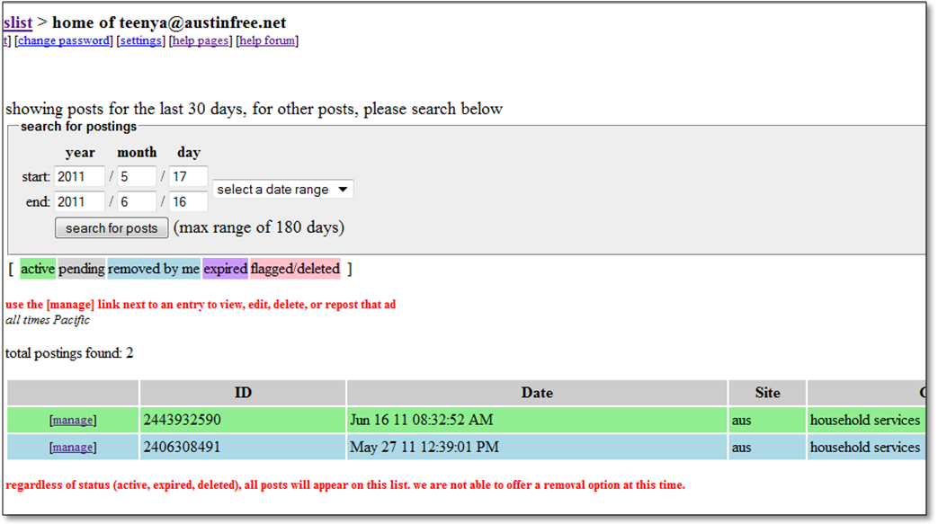
Search Feature – Select a date range to search within and click “search for posts”
Status Color Legend: (In order of listing) Green = Active, Grey = Pending, Blue = Removed, Purple = Expired, Pink = Flagged/Deleted
2
A screen like the one below showing your posting should appear.
3. To edit the posting click on “Edit this Posting”. To delete the posting click “Delete this posting”.
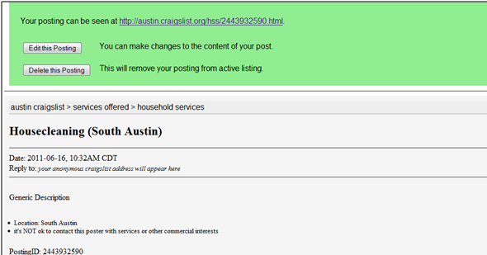
3
This will bring up your posting so that you can make your changes.
4. Once you have completed your changes and are satisfied with the way your posting reads click “Continue”.
If you decide that you liked your original posting better than the edited version click “Revert to Saved”.
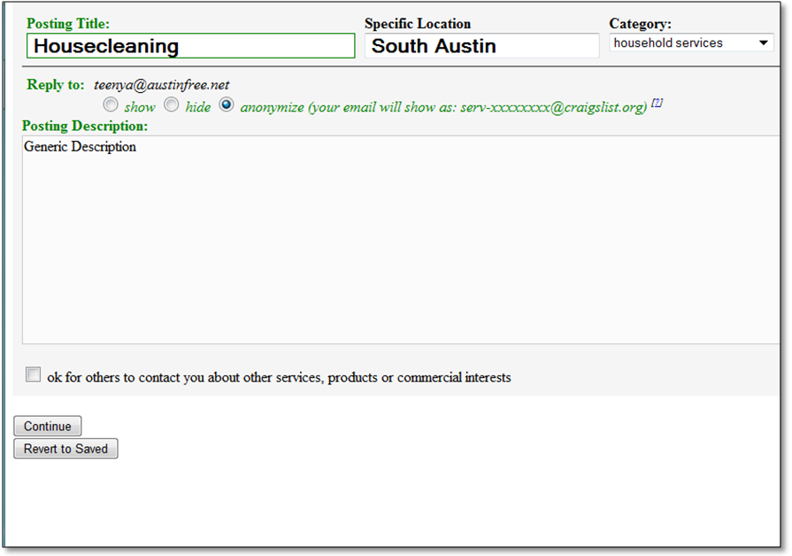
4

5. Review your posting for mistakes, if you are satisfied with the posting click “Continue”. If you need to make more changes click “Edit Again, and if you decide to return the posting to the original version click “Revert to Saved”.
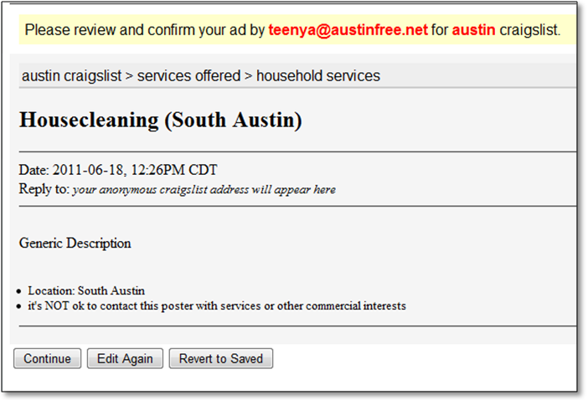
5
6. A Captcha screen like this one will appear – enter the words/letters you see EXACTLY how they are on the screen and click “Continue”.
6
A screen like the one below will appear, to view your posting click the link at the top. If you are done with your posting you can logout (top right hand side of the screen), or you can return to the home page of craigslist by clicking “craigslist” (top left hand side of the screen).
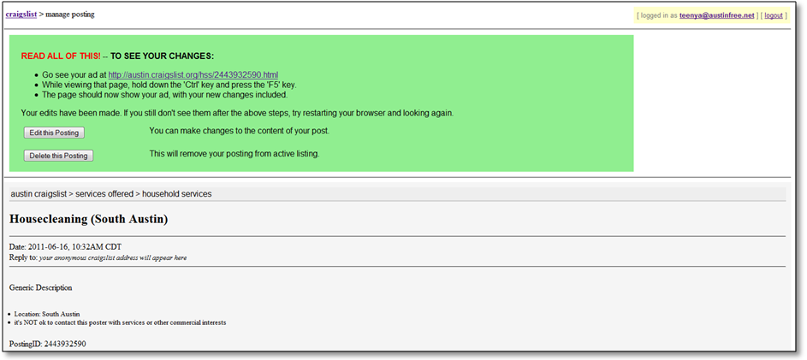
Click this link to view your post
How do I repost an old ad?
- Log in to your user account.
- Locate the post you want to re-post, click on its title.
- Click "Repost this Posting."
- Select the category for the post.
- Verify the title and body of your new post edit if necessary, click "Continue."
- Check the preview of your post, then click "Continue" to publish the post.
  - Note you may be required to repeat the Phone Verification process explained on pages 6 thru 8 of this handout in order to repost.

Materials adapted from parts of CraigslistTM Help: http://www.craigslist.org/about/help/

