 Internet Safety

Lesson 5- Protecting Your Financial Transactions

PG 2: When is a Website Secure for Financial Transactions?
Before sending any sensitive or financial information online, you want to know that you are communicating with a secure site. Secure Sites make sure that all information you send is encrypted, or protected as it travels across the Internet. The https address heading and your browser's Security Symbol are two signs that indicate you are on a secure site.

Https
Web addresses either begin with http or https. If the address is https then the information you send to it is encrypted and will look like gibberish if intercepted by cybercriminals.
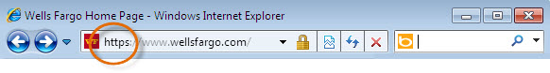Https

Security Symbol
Your browser will use a Security Symbol or a Lock to indicate that the browser verifies the website is a secure site. As seen in the examples below, the look and location of each browser's Lock can be slightly different.
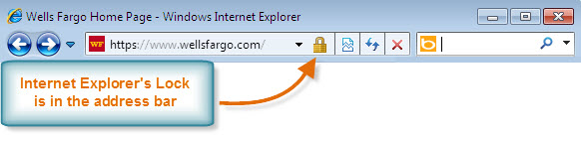Security Symbol for Internet Explorer
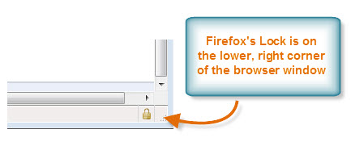
Security Symbol for Firefox
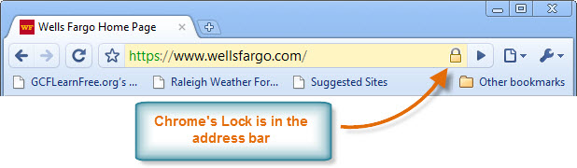Security Symbol for Chrome

PG 3: Security Alerts and SSL Certificates

SSL Certificate
Secure Sites have an SSL Certificate. An SSL Certificate does two things. First, it acts like a virtual passport or driver's license. It means, "I am who I say I am." Second, it enables encryption. If a site does not have an SSL Certificate, the address will begin with http instead of https, and your browser will not show a Lock. If it does have an SSL Certificate, you can access it by double clicking on your browser's Lock.

What Should I Look for on an SSL Certificate?
- Issued To: Check here to make sure the website you are doing business with matches the website on the certificate.
- Issued By: Make sure the Certificate Authority that issued the SSL Certificate to the website is trustworthy. There are many different Certificate Authorities, and like all companies, some are more trustworthy than others. Verifiable SSL Certificate Authority companies that you are likely to see are VeriSign, RSA Data Security, Thawte, Geotrust, GoDaddy, and Comodo.
- Validity: Make sure the SSL Certificate is not expired. If it is expired, your information is not guaranteed to be encrypted.

The following is an example of an SSL Certificate accessed by Firefox. Your browser's SSL Certificate may look different than Firefox's, but you should have access to the same information.
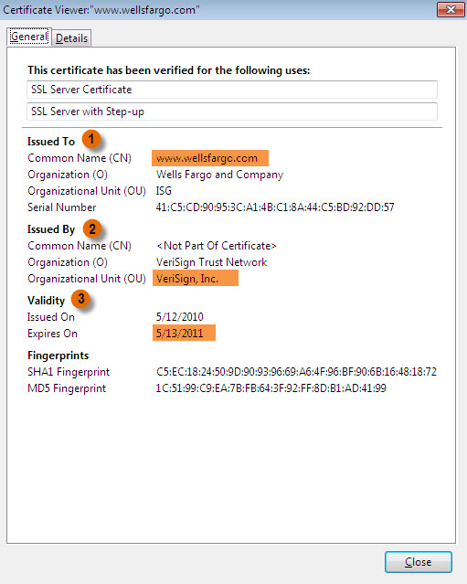
SSL Certificate for Firefox

Security Alerts
Current versions of Internet Explorer, Firefox, and Chrome verify SSL Certificates for you. They will alert you if the certificate is not up to date, or if it was not issued from a trusted Certificate Authority. To guarantee these alerts, make sure you are always running the most updated version of your browser. For more information on these alerts, choose from the following:
Internet Explorer 8 uses a four-level color system to alert you about Certificate Validation.
FireFox verifies certification with its One-Click Site ID.
Chrome uses basic warning messages and some color-coded domain highlighting to alert you about certificates.

