Beginning Class, Lesson 1:
Computer and Windows Basics
Meet and learn to communicate with your new best friend
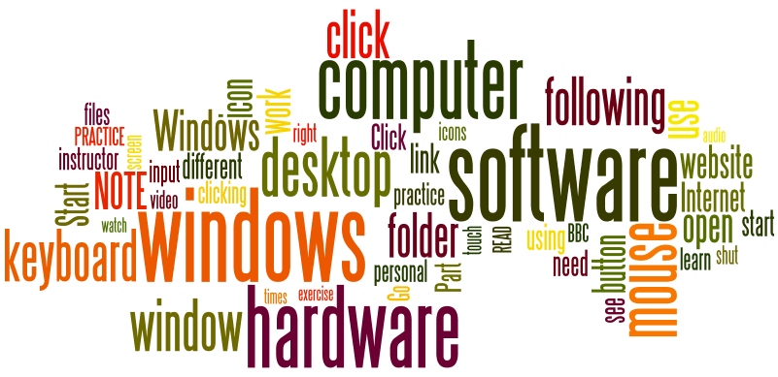
Lesson 1 objectives:

In Section A, students will:
- Become more familiar with using a computer mouse.
- Become more familiar with using a computer keyboard.
- Become more familiar with using a computer touch screen.
- Learn about basic computer terminology and important parts of a computer desktop.

In Section B, students will:
- Learn about computer windows.
- Learn how to open computer windows.
- Learn how to close computer windows.
- Learn how to make computer windows larger or smaller to make them easier to work with.

BROUGHT TO YOU BY

Beginning Class, Lesson 1 Concepts
- Learn about important parts of a computer desktop:
Recycle Bin icon | 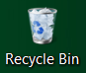 | When you delete an object, Windows sends it to the Recycle Bin.
Program, folder, and document icons | 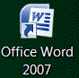 | These icons allow you to access programs, folders, or documents by clicking on them. Programs such as calculator, notepad, or email can be easily accessed by clicking on their icons.
Start button |  | A round button with the Windows symbol. It's a launching pad for applications. It is also used to turn the computer off.
Taskbar | The Taskbar is the access point for programs displayed on the desktop.

- Learn about computer windows:
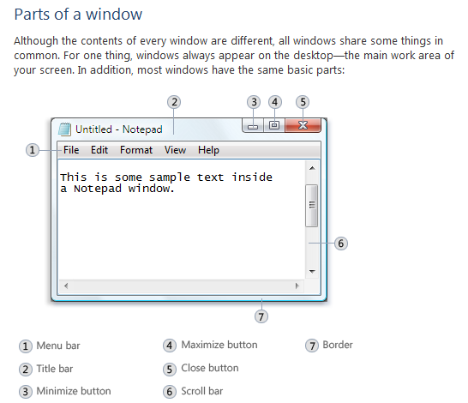

- Learn how to open computer windows:
- Use the mouse or the touch screen to move the cursor arrow over the program icon you want to start.
- Double-click on the program icon.
- Learn how to close computer windows.
- Learn how to make computer windows larger or smaller to make them easier to work with.

The Computer or Internet Explorer window will open.  What do you see inside a window?  Find the Close button on that window and click on it.  Practice this a few times. | 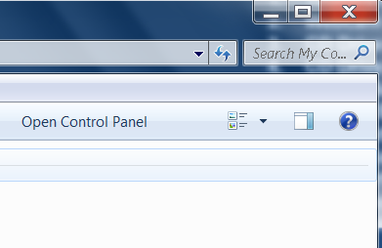
Open Internet Explorer by double-clicking on its icon.  Once the window is open, click on the Minimize button.  Look at the taskbar to find the minimized window.  Practice this a few times. | 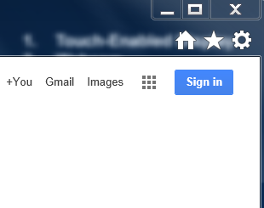
Open Internet Explorer by double-clicking on its icon.  Once the window is open, click on the Maximize button.  Observe the window and see the changes.  Practice this a few times. | 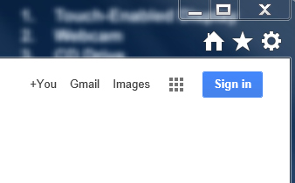

Beginning Class, Lesson 1 Homework
- Practice your mouse skills by visiting the “mouse exercise” website shown at right or visit this website to practice: http://bit.ly/mousercize. (Ask a computer center volunteer to help you find these if necessary.) You can do either the practice exercises, the games, or both. Try to practice or play for at least 30 minutes this week.

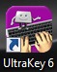
- Practice your typing skills. You can either use the learn-to-type program on the computer center computer (shown at right) or visit the “Keyboard exercise” website shown above: http://bit.ly/webtyping . (Ask a volunteer to help you get started if necessary.) Try to practice or play for at least 30 minutes this week.

Questions for next time:
____________________________________________________________________________________________________________________________________________________________________________________________________________________________________________________________________________________________________________________________________________________________________________________________________________________________________

