Beginning Class, Lesson 2:
World Wide Web Basics
Have your new best friend show you around the world
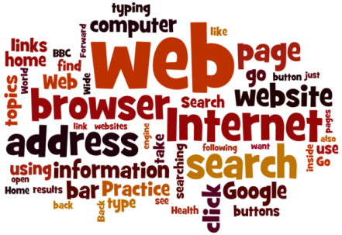
Lesson 2 objectives:

In Section A, students will:
- Learn about different kinds of web browsers.
- Learn how to start or open a web browser.
- Learn how to search for information on the Internet.

In Section B, students will:
- Learn about web addresses.
- Learn how to use the web address bar.
- Practice typing in web addresses.
- Learn and practice the following icons:
  - Back arrow
  - Forward arrow
  - Home
  - Refresh command
- Use Google Maps to look for directions or to look up information about a place.
BROUGHT TO YOU BY
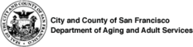

Beginning Class, Lesson 2 Concepts
- Learn about different kinds of web browsers:

When you go onto the Internet, you’ll generally be doing so using a web browser. A web browser (often just called a browser) is the program you start when you want to look at a website. Some of the more common web browsers are shown below. Please note: most people find that Google Chrome works best on the BTOP computers.

Web browser | Google Chrome | Internet Explorer | Mozilla Firefox
Icon | 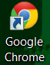 | 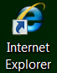 | 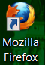

- Learn how to start or open a web browser:
- Use the mouse or the touch screen to move the cursor arrow over the icon for Google Chrome (or another web browser).
- Double-click on the program icon.
- The web browser will open up to the computer’s “home page.” (At senior center computer centers, this will be http://sfbtop.wikispaces.com).
- To close the web browser, click the “close button” (the red button with the x that’s located on the upper right-hand corner of the screen).

- Learn how to “browse” links on a web page:
- On a web page, if you see your cursor change from an arrow to a pointing finger, that means that you have found a link that will take you to a different web page. Most links on the web are underlined in blue.
- Once the cursor has turned into a pointing finger, click on the link to go to a new page.

- Learn and practice the following parts of web browser:

Address bar | 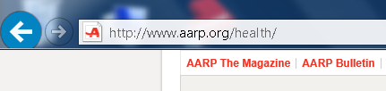
Back arrow
Forward arrow

Refresh command | 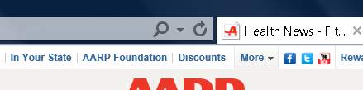
Home | 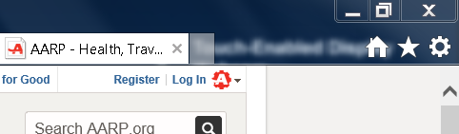

- Learn about web addresses:
- The web address gets typed in the web browser’s address bar.
- Most web addresses start with www
- Most web addresses end with .com (for businesses), .org (for nonprofit organizations), .edu (for education), or .gov (for government agencies).
- Web addresses must be spelled and typed in correctly, or the web browser will not take you to the correct page.
- If you’re not sure how to type in a web address, do a search for the website (see instructions below for doing a web search) and follow the link from the search results page.

- Learn how to search for information on the Internet using the links on the sfbtop.wikispaces.com website:
- Open up a web browser (see directions above).
- Find the box that says “Search the Internet.”
- Click on the link for Google. (Remember, your cursor will change from an arrow to a pointing finger.)
- Type your search question in the search box at Google.
- Press the Enter key on the keyboard

- Learn how to search for information on the Internet by using the address bar: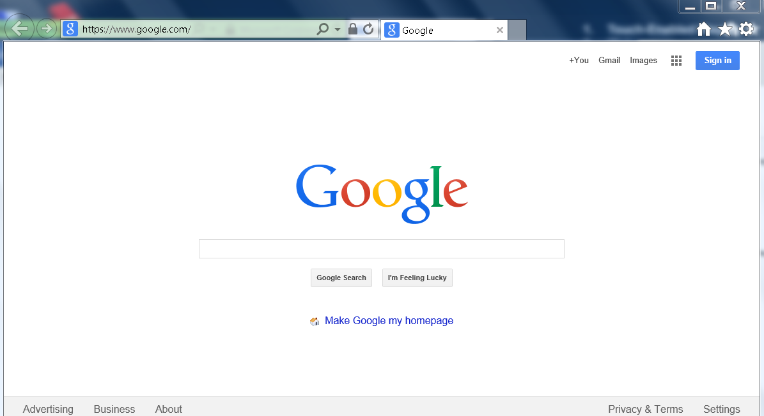
- In the web browser, find the address bar and type in: www.google.com
- Press the Enter key on the keyboard.
- Your web browser will take you to the Google website.
- Type your search question in the search box at Google.
- Press the Enter key on the keyboard.

- Learn tips for savvy web searches:
- Be as specific as you can when searching by using more than one key word. For example, to find a plumber in your local area, type in plumber and the name of your home town.
- To search for a phrase, put it in quotation marks, such as "polar bear".
- You can choose to search for one word but not include another by using a minus sign. For example to search for bears, but not polar bears you would put: bear -polar
- Try not to write full sentences or questions when you are searching; just use key words.
- Check your spelling when using a search engine.
- You can also search for images on the Internet. On your search engine there will be an option for searching for just images.

- Use Google Maps to look for directions or to look up information about a place:
- Click on the Google Maps App.
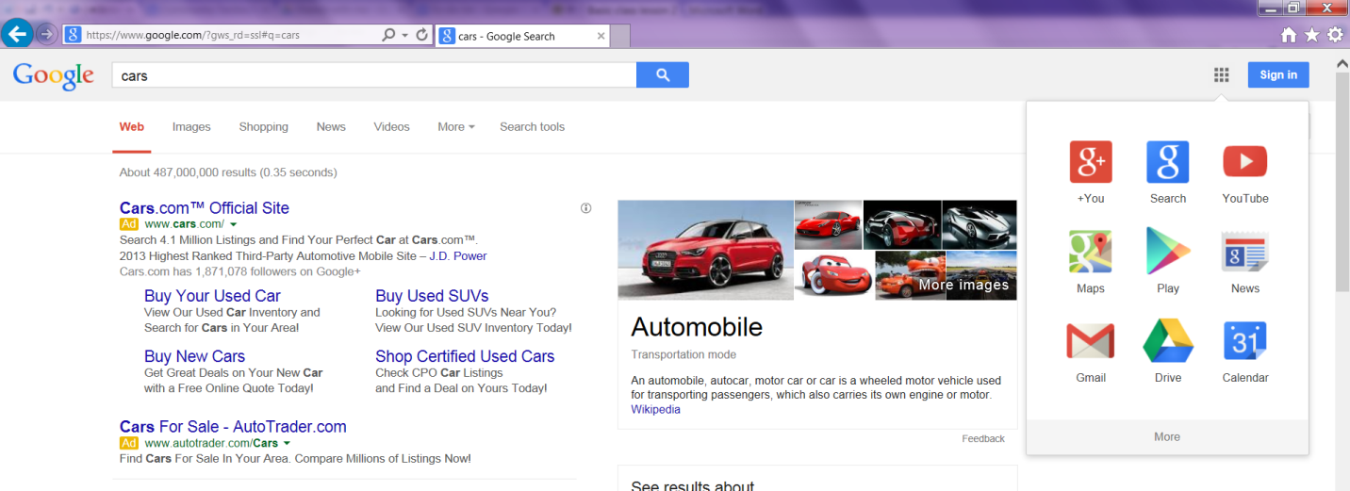

- It will take you to the Google Maps page.
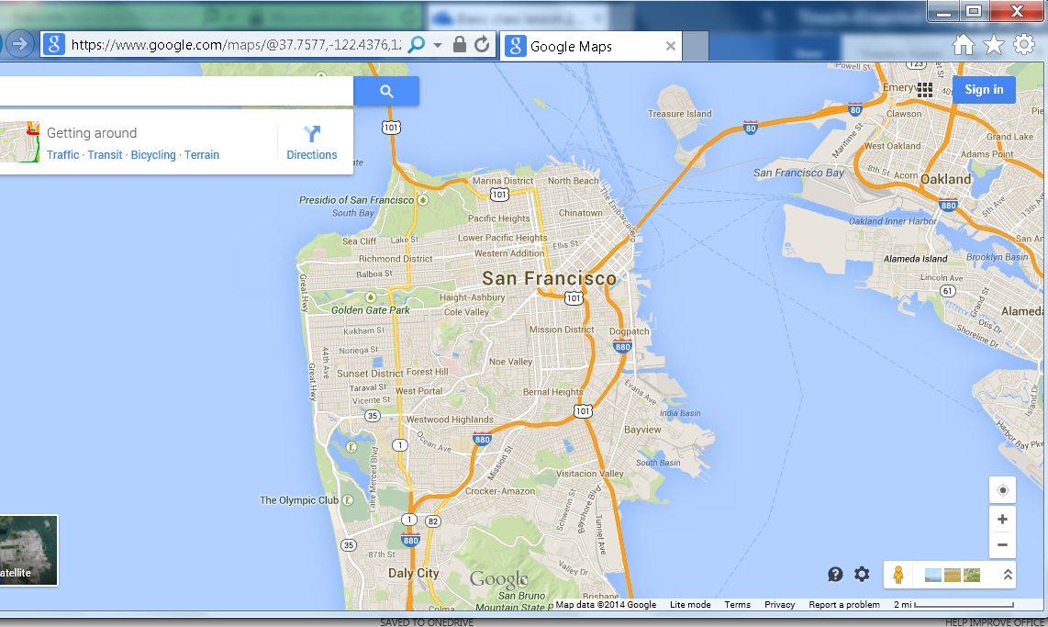

- Type in the name or address of the place you would like to find in the search box.
- Press the Enter key on your keyboard.
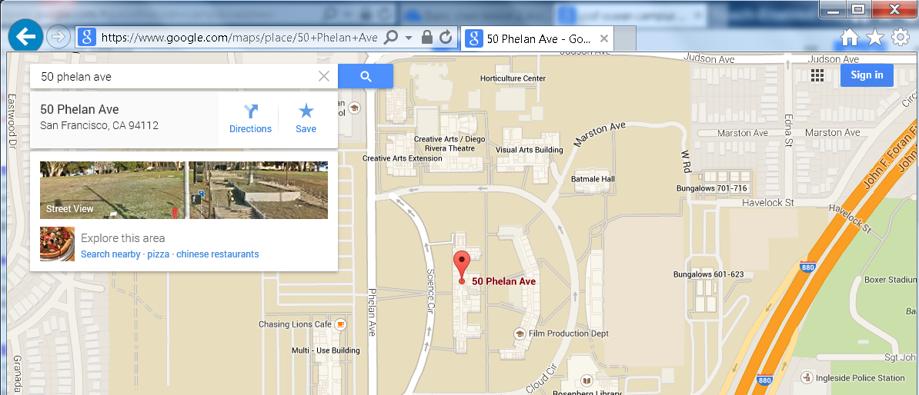
- Google Maps will show you a map of the place name or address that you typed in.

Beginning Class, Lesson 2 Homework
- Visit sfbtop.wikispaces.com. Try to spend at least 30 minutes and click on at least five links from that web page. Make a note of your favorite links or websites to share with the class next time.

- Use Google Maps to find a map of your childhood hometown and a map of Washington, D.C.

- Do a Google search on two topics of interest to you. Make a note of your three favorite websites to share with the class next time.

Questions and favorite websites to share for next time:
____________________________________________________________________________________________________________________________________________________________________________________________________________________________________________________________________________________________________________________________________________________________________________________________________________________________________________________________________________________________________________________________________________________________________________________________________________________________________________________________________________________________________________________________________________________________________________________________________________________________________________________________________________________________________________________________________________________________________________________________________________________

