Beginning Class, Lesson 3:
Email Basics
Start communicating with friends and family using emails
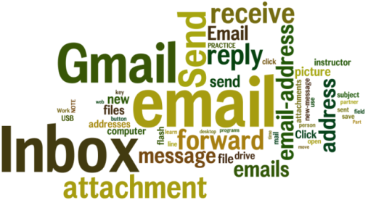
Lesson 3 objectives:

In Section A, students will:
- Learn how people use email.
- Create a Gmail account or practice using the Gmail account they already have.
- Learn about the parts of an email address.
- Share their email address with 1 or 2 other people.
- Write and send an email.
- Receive some emails.
- Reply to an email.
- Forward an email message.
- Learn to manage their email messages by saving and deleting the messages.

In Section B, students will:
- Practice signing in to their Gmail accounts.
- Practice signing out of their Gmail accounts.
- Learn about email safety.
- Learn about email scams.
- Learn about spam emails.
BROUGHT TO YOU BY

Beginning Class, Lesson 3 Concepts:
- Learn how to get to the Gmail website by using the links on the sfbtop.wikispaces.com website:
- Open up a web browser (see directions in Lesson 2).
- Find the box that says “Email.”
- Click on the link for Gmail. (Remember, your cursor will change from an arrow to a pointing finger.)

- Learn how to get to Gmail website by using the address bar:
- Open up a web browser (see directions in Lesson 2).
- In the web browser, find the address bar and type in: www.gmail.com.
- Your web browser will take you to the Gmail website.

- Sign in to your Gmail email account:
- Enter your email in the Email box.
- Enter your password in the Password box. You must use the same password you used when you set up the account.
- Click the Sign in button.

- Learn the parts of an email message:
An email is made of different parts that need to be complete in order for the message to be received. The email is divided into the header and the body.  1. The header contains the receiver's email address, which you enter on the To line.  2. The header also contains the subject line. One of the most important rules is always to enter a meaningful subject line for your email. The subject line question is vague, but the subject line question about computer class is clear. Enter your subject line after the Subject field.  The header is usually what most people first see when they go into their email accounts.  3. The body of the email is the actual message that you’re sending.  Look at the following example of an email.  4. Go ahead and mark the header part and the body part. | 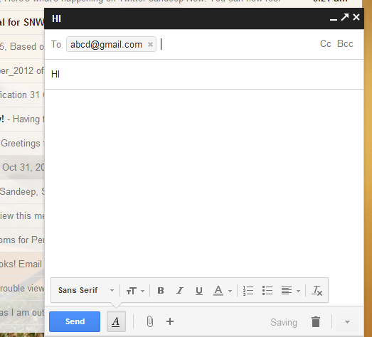

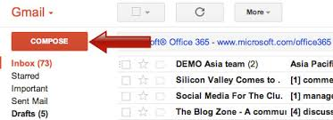
- Write and send an email:
- Go to the Gmail website. (See instructions above.)
- Log into your Gmail account. (See instructions above.)
- Click on the Compose button to start composing a new email.
- Click inside the box next to the To: and enter the email address of the person you want to send an email to. Your instructor or your computer lab partner is always a good practice subject.
- Click inside the box next to the Subject: and enter a meaningful subject for the email.
- Move the cursor to the Body field. You can now start writing your email.
- Once you finish your email, click on the Send button at the bottom.

Your email is being sent, and the receiver should get it right away.

- Receive some emails:

Once your instructor or partners have sent you some emails, you will start to have emails coming into your Inbox.

Click on the Inbox link on the left side.

The Inbox link is in bold with a number next to it.

The number next to the Inbox indicates how many unread emails you have in your Inbox.

- Respond to an email message:
1. Inside your Inbox, new emails are indicated in bold. Once you read an email, it will turn to the regular font style.  2. Click on Reply to reply only to the person who sends that message.  3. Click on Forward to forward a message to another person, but not back to the sender.  4. Click on Reply to all to reply to a message that was sent to more than one person. All the receivers on the list will see your reply. | 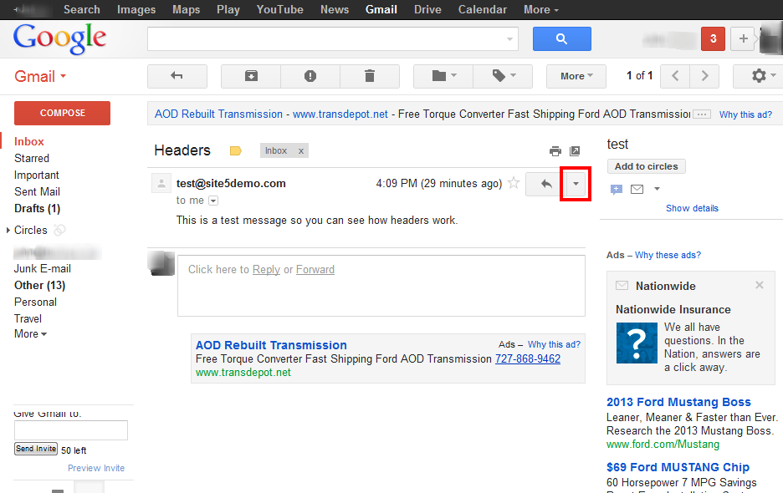

NOTE: Every email program has Reply, Forward, and Reply All buttons;
however, they may be located in different places.

- Delete an email message:
- Emails coming into your Inbox will stay there until you move or delete them.
- Click on Delete to delete the emails you don't want to keep. These emails will be removed from your Inbox and placed inside the “Trash” folder.
- Deleted emails stay in the Trash folder until you empty the Trash folder or until they have been there for 30 days.

- Save an email message:
- Emails coming into your Inbox will stay there until you move or delete them.
- Click on the Archive button in Gmail to “archive” or “save” a message.
- When you archive a message, you remove the message or messages from your inbox, so you won't see them displayed on the main page.
- Archived messages still exist in the All Mail folder. You can still view them. You can see them again either by clicking the All Mail button or by
searching for some word or phrase in the email.

- Dealing with spam:
- If you think that an email message is a “junk” or “spam” email, you can click on the Report Spam button.
- The Report Spam button removes an email from your inbox and puts it in your Spam folder.
- Clicking on the Report Spam button also tells your email program to send other email messages like the one you reported to the Spam folder automatically.

- Learn about the spam folder:
- Gmail comes with a “spam filter” or “spam blocker” that automatically places suspicious-looking emails into the Spam folder.
- NOTE: Other email programs may call the Spam folder the Junk Email folder.
- Real messages from people you know can sometimes end up in the spam folder, so it’s a good idea to look inside your spam folder from time to time.
- Be very careful checking the Spam folder. DO NOT click on emails sent by people you don't know.

- Sign out of your Gmail email account:
- If you use Gmail on a public computer, it is VERY important to sign out of your email account when you are finished using your account. Otherwise, another person could have access to your personal information.
- To sign out, look for your Gmail address in the upper right side of the screen, underneath the web address bar.
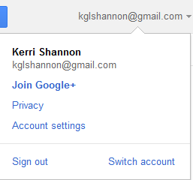
- When you click on your email address, a menu will appear.
- Click on “Sign out.”

- Learn about email scams:
- If you don’t immediately recognize the sender, don’t open it, just delete it.
- Never send personal information via email. Call instead.
- Never click on a link from an email unless the email is from a friend and sounds like it is from your friend. Sometimes, scammers make an email look like it’s from your friend. If a message says it’s from a friend, but the message sounds strange, call or talk to your friend before clicking on the link in the email or replying to the email.

Beginning Class, Lesson 3 Homework:
- Send an email to your class teacher or volunteer helper. In the email, tell them one or two things that you have learned by taking the class.
- Find Reply, Reply to all, and Forward on your email message. Reply to an email that was sent by someone you know.
- Do a Google search for “email safety for seniors.” Email your class teacher or volunteer helper with one new safety tip you learned, or the web address for a helpful safety website.
Questions and email addresses to share for next time:
______________________________________________________________________________________________________________________________________________________________________________________________________________________________________________________________________________________________________________________________________________________________

