Beginning Class, Lesson 4:
Social Networking and Facebook
Discover different ways of catching up with friends online

Lesson 4 objectives:

In Section A, students will:
- Learn about social networking.
- Learn about some of the more common social networking websites and tools.
- Create a Facebook account or practice using the Facebook account they already have.
- Learn about Facebook’s privacy settings.
In Section B, students will:
- Share their experiences with Facebook and other social networking sites since the last class.
- Practice logging in to their Facebook accounts.
- Practice logging out of their Facebook accounts.
- Add friends to their Facebook accounts.
- Post updates to their Facebook wall.
BROUGHT TO YOU BY
- Respond to what they see on their Facebook wall.
Beginning Class, Lesson 4 Concepts:

- Learn how to get to the Facebook website by using the links on the sfbtop.wikispaces.com website:
- Open up a web browser (see directions in Lesson 2).
- Find the box that says “Social Networking.”
- Click on the link for Facebook. (Remember, your cursor will change from an arrow to a pointing finger.)

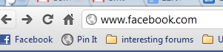
- Learn how to get to the Facebook website by using the address bar:
- Open up a web browser (see directions in Lesson 2).
- In the web browser, find the address bar and type in: www.facebook.com.
- Your web browser will take you to the Facebook website.

- Log in to your Facebook account:
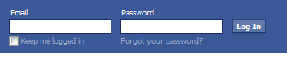
- Go to the Facebook website (see instructions above).
- Enter your email address in the email box. This is the same email address you used when you set up your Facebook account.
- Enter your password in the box. You must use the same password you used when you created the account.
- Click the Log In button.

- Learn about Facebook’s privacy settings:
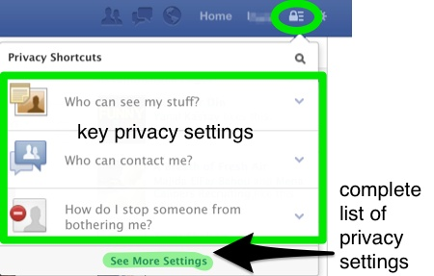
- To see the privacy settings for your Facebook account, click on the padlock on the far right hand side of your screen.
- When you click on the padlock, a menu will appear.
- Click on “See More Settings” to look at and change your settings. (Please note: Facebook changes its rules and settings for privacy very often. It’s a good idea to check your privacy settings every month or so, and change the settings to the level of privacy that you think is appropriate.)
- You can use the privacy settings to control whether the pictures and other information you put on Facebook is Public (meaning that anyone with a Facebook account can see it), to be shared only with your friends, or to be shared with an even smaller group of people.
- Add friends to your Facebook account:
- You can look for people you know on Facebook by clicking on the “Find Friends” link.
- The “Find Friends” page will suggest people that you might know. You can click on any of the names or pictures or names to look at the profiles. You might want to do this to help you decide whether the Facebook page you’re looking at belongs to the person you think it does.
- When you find a person you know, you can invite them to be a friend on Facebook by clicking on the “Add Friend” button.
- Another way to look for people you know on Facebook is to type in the names or email addresses of your family members or friends in the search bar on Facebook.

- Post updates to your Facebook wall:
- Go to the Facebook website.
- Log into your Facebook account.
- Find the Status box at the top of the page.
- Click in the Status box and type in the news or thought you wanted to share with your friends and family on Facebook.

- Respond to what you see on your Facebook wall:
- Once you have a few friends on Facebook, you’ll be able to see their status updates, plus the pictures, videos, and articles they share on their page.
- If you like what they have said or shared, you can click on the Like button.
- If you want to say something about what they have said or shared, click on the Comment button and type in
your comment. Everyone who can see your friend’s original comment will be able to see your comment as well.
- If you like a picture or article they shared, click on the Share button to put the same picture or article on your Facebook wall.

- Log out of your Facebook account:
- If you use Facebook on a public computer, it is VERY important to log out of your Facebook account when you are finished using your account. Otherwise, another person could have access to your personal information.
- To log out, click on the arrow button on the far right hand side of your screen.
- When you click on the arrow, a menu will appear.
- Click on “Log out.”

Beginning Class, Lesson 4 Homework
- Spend at least 30 minutes using Facebook this week. If you need help, ask a computer center volunteer to help you.
- Invite at least three people to be Friends with you on Facebook.
- Write two status updates for your Facebook page.
- Respond to a picture or comment on another person’s Facebook page.
Questions to share for next time:
____________________________________________________________________________________________________________________________________________________________________________________________________________________________________________________________________________________________________________________________________________________________________________________________________________________________________

