Intermediate Class, Lesson 1:
File and Folder Basics
Meet and learn to communicate with your new best friend

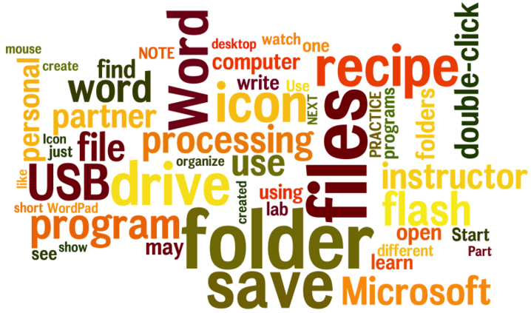
Lesson 1 objectives:

In Section A, students will:
- Learn about computer files and computer folders.
- Use a word processing software to create a file.
In Section B, students will:
- Learn how to insert and remove a USB Flash Drive.
- Learn how to save personal files into an USB flash drive.
- Learn how to find the files saved in the USB flash drive.
- Learn how to safely remove a USB flash drive.
BROUGHT TO YOU BY

Intermediate Class, Lesson 1 Concepts
- Learn about computer files and computer folders.

Understanding file management is important because it will help you organize, store, and retrieve files and folders efficiently. Whenever you save a file on your computer, you are saving it to the computer's hard drive or to a mobile device.
Computers use files and folders to store information in much the same way that you would use a filing cabinet and cardboard folders to store paper such as letters, bills, and other documents.

- Individual documents  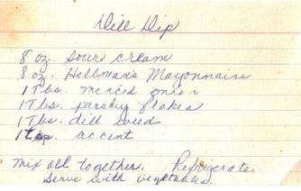 | become computer files.  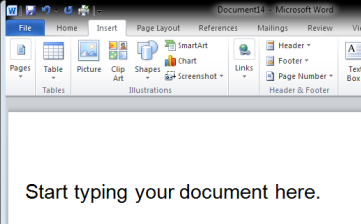
- Cardboard folders  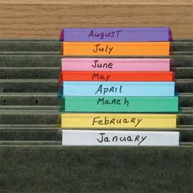 | become computer folders.  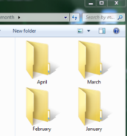
- Filing cabinet drawers become the hard drive. | 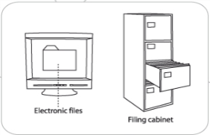

- Use word processing software to create a file.
- Save a file.
1. From the desktop, find the Office Word 2010 icon. Use the mouse and double-click with the left button on the icon.

Or:
2.Use the mouse and click on the Start button found
in the lower left corner. Click on All Programs,
find Office Word 2010, and click with the left button.
3. Watch your instructor or computer lab partner open up the word processing program the class will be using.  A blank page opens up. This is where you can start typing up your recipe. | 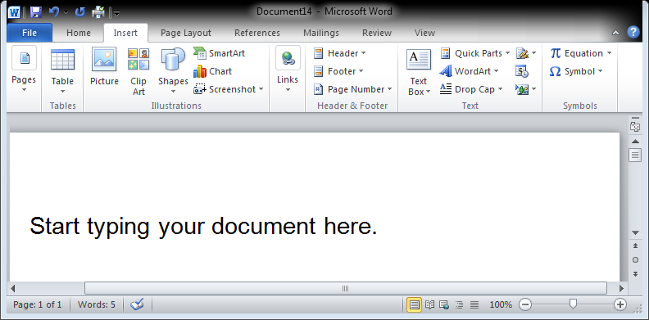
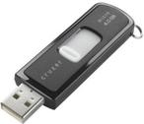
- Insert a USB Flash Drive into a computer.
When you are using a public computer, it is a good idea to save all your personal files into a mobile USB flash drive. It will be your personal filing cabinet.
1. Find the USB drive on your computer. Ask your instructor or a computer lab tutor for help if necessary. Place the USB flash drive into the slot you found. | 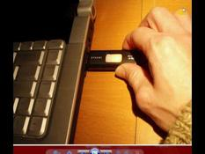
Observe what appears in the lower right corner of the computer screen (this notice may not show up if you have done this process before). | 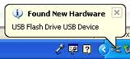

• Safely remove a USB Flash Drive.
To prevent damage to the removable USB flash drive, there is a proper way to remove it from the computer. Find the “ safe to remove” icon. It is usually located on the lower right corner of your computer screen. Ask your instructor or a computer lab volunteer help you if you can’t find it yourself. | 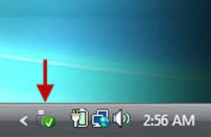
Click on the “safely remove” icon.

A new box will appear on screen. Select “Eject USB Flash Disk.” | 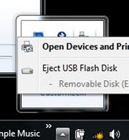

• Save a file to a USB Flash Drive.
When you are finished working on your document, you will want to SAVE your work. The first step is to put your mouse on the SAVE button and click on it.
The program will ask you to give your document a name. Give it a name that will help you remember what it’s about.
You can also tell the program where to put your file. To save it to your USB drive, click on the USB DISK icon. (It will usually be on the left under the “Computer” or “My Computer” icon.) You can also put a folder inside a folder. (In the example to the right, you could place the file “My recipe” either in the folder “Doris Cheng” or leave it outside of the folder.
Click on the Save button to save your document.

Intermediate Class, Lesson 1 Homework
- Practice inserting and safely removing a USB flash drive to your computer. Try to insert and remove it at least 5 times. Make a note of any “tricks” or questions you can share with the class for next time.
- Create a file using a word processing program. You could write a recipe or a list of things you’ve learned to do on the computer. Save the file to a USB drive.
- Practice finding, opening, and closing the word processing file you created in homework #2. . Make a note of any “tricks” or questions you can share with the class for next time.
Questions for next time:
__________________________________________________________________________________________________________________________________________________________________________________________________________________________________________________________________________________________________________________________________________________________________________________________________________________________________

