Intermediate Class, Lesson 2
Internet Safety
Protect me and my new best friend with best practices

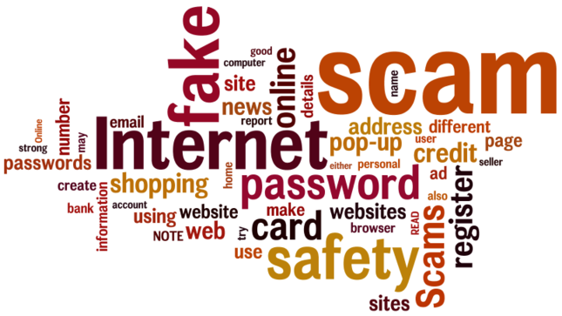

Lesson 2 objectives:

In Section A, students will:
- Learn why a strong password is important.
- Learn how to create a strong password.
- Learn how to register on a website.
- Learn how to recognize safe websites for shopping.
In Section A, students will:
- Learn how to deal with pop-ups and malicious sites.

BROUGHT TO YOU BY

A good password should be easy for you to remember but difficult for anyone else to guess. But we're often advised — or forced — to create unmemorable passwords using rules that confuse us and provides little protection against real threats. So to choose a good password, we must understand those threats.

Threats to your password
- You can be persuaded to reveal your password — it’s very common.
- Your password can be stolen by "malware" — a malicious program on your computer that watches keystrokes as you type or if you use the "remember password" feature on a web page. In any of these cases, it doesn't matter how complicated your password was.
- Websites with login pages store passwords in a file, and these files often get stolen.
- More complex passwords would be slower to break.
- An attacker might systematically try user names and passwords at the login page of some popular online service. This is called "brute force," and it's preventable: the page should lock out further attempts after a small number of failures.

What makes a strong password?
- One of the best techniques is to choose a memorable phrase containing the same number of words as the desired password length in letters and use the first letter of each word to create an acronym to use as your password.

Why do I need to register on different websites?
- There are many different types of websites, such as news sites, banking sites, and shopping sites, that either require or recommend that you register.
- Some websites are for members only, and you need to register to gain access.
- To protect your privacy and financial safety, it is very important to create good, easy-to-remember usernames and strong passwords.
- They will often use your email address to send you a confirmation that you've registered properly.

Click on Sign up to register

on the CNN news website.

Click on Register Now to

register on the The New York Times

news website.

Click on Register to register on the

San Francisco Chronicle news site.

How do I know if I'm shopping on a safe website?
- When you’re shopping online, it's essential to make sure that you're dealing with a reputable business.
- There are several easy checks you can make that will help protect you against dishonest or unreliable traders and fraudsters.
- Anyone can create a web page, so there's no immediate way for a shopper to tell whether an online shop is genuine at first sight. So there's more to being safe than just ensuring your card transaction is encrypted.

Things to watch out for
- Firstly, ask yourself whether the offer is realistic. If it sounds too good to be true, it probably is.
- Quite a lot of stolen and substandard goods get offered at seemingly huge discounts by small traders on auction and free advertisement sites.
- Beware of sites that only give a mobile number.
- Consumer sales sites must (by law) also publish some obligatory terms and conditions, particularly about cancellations, returns, and refunds. Check the shipping charges too. If you can't see what they will be until the final stage of the checkout, the seller is not playing by the rules: they should be clearly set out in the terms and conditions.
- It’s worth doing a web search for customer comments in blogs or online communities.
- Finally, if a site asks for your card details when you respond to a "free offer," it's certainly fraudulent. No free offer involves prior payment, and no legitimate seller is permitted to hold your full card details except while they are currently processing a specific purchase.

What are pop-up windows?
- Pop-ups are a form of online advertising intended to attract web traffic or capture information. Pop-ups appear in a separate, usually small, browser window. These windows may include advertisements or ask you to enter personal information such as your credit card account number, expiration date, and security code. By clicking on a link in a pop-up, spyware or malware may be downloaded onto your computer without your knowledge. Pop-up windows that occur even while you are not browsing the Internet may be an indicator that your computer is infected by spyware or malware. There are many software programs that block pop-up

You may see a pop-up like this: | 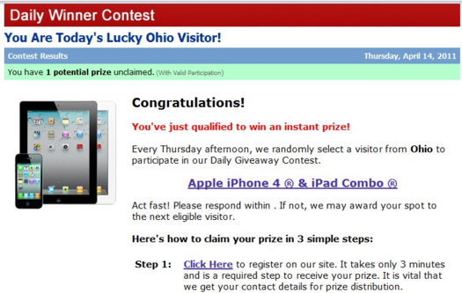
If you try to leave these types of websites, another pop-up window will come up and suggest that you stay. | 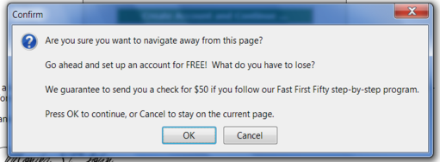
From this Daily Winner Contest, you will see the testimony from previous winners such as Jennifer Layton from San Francisco, California. | 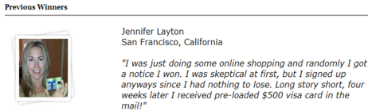
And now Jennifer Layton from Akron, OH. | 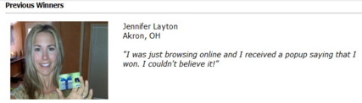
And the same Jennifer Layton from Round Rock, TX. | 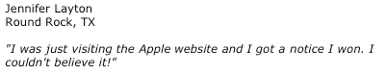

And another Jennifer Layton from South Pasadena, CA?

What do you think?

Questions for next time:
________________________________________________________________________________________________________________________________________________________________________________________________________________

