Beginning Class, Lesson 4:

SKYPE
Get connected with your friends and relatives from far away

Lesson 4 objectives:

In Section A, students will:
- Learn what Skype is.
- Learn how Skype is used.
- Know how to set up a Skype account.
- Know how to find and add contacts to your Skype contact list.
- Make free Skype – Skype calls.
- Make free video calls.

In Section B, students will:
- Practice signing into Skype.
- Learn how to set up Skype at home.
- Learn how to set up Skype on your computer or smartphone.
- Use Skype to call landline phones and mobile phones.
BROUGHT TO YOU BY
Installing Skype on your computer:
From your computer, open your web browser and type www.skype.com inside the address bar.  Skype software can be installed on Windows computers, Apple computers, mobile phones, and other devices.  You will see the Skype icon such as  or on the computer. | 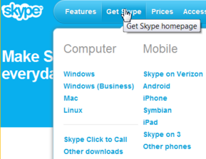

Set up a Skype account:
Double-click on the or icon from your computer to open the Skype program.  Click on Create a new account to begin the setup process. | 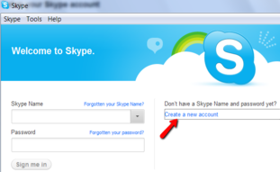

After you finish setting up your Skype name and password, copy down your Skype name and password below for further references. Do not share your password with anyone else.
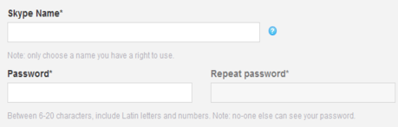
Add contacts to your contact list:
Once you sign in to your Skype account, you need to add your friends to the contact list to start talking to them. Choose Add a Contact tab from the Contacts menu.  Or go to the Add a Contact section and click on it.  The Add a contact window opens up. Enter the first Skype name you collected into the Skype Name box and click Add. . | 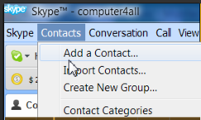  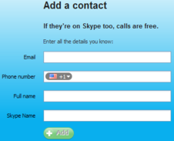
For security reasons, Skype sends out a contact request to the person you wish to add to your Skype contact list. Click on Send request after you add that person into your contact list. | 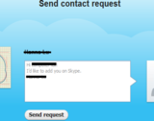
When your friends or lab partners add your Skype name to their contact list, you will get a contact request showing up in your Skype account. The next to the Contact request means that you have one request from someone. Click on the Add to Contacts button when you know the request is from your friend or lab partners. | 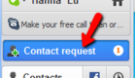  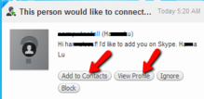

Make and Receive Phone / Video Calls:
If you are the caller, find and click on your partner's Skype name from your contact list and click on Call. |  | 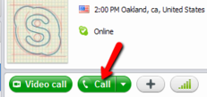
If you are the call receiver, click on Answer when you get a call. |  | 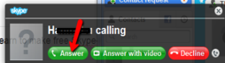

Click on the end call icon when you finish your conversation.
When calling, click on Video Call. | 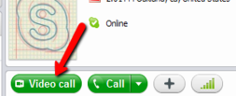
When receiving, click on Answer with video. | 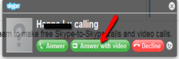

Click on the end call icon when you finish your conversation.

If you have a smartphone or a tablet such as iPhone, Android phone, or iPad, it is easier if you can find someone who is familiar with your device to set up the Skype app on your device.

You can check if your mobile device is on the Skype-compatible list by clicking on Get Skype from the top menu.

Once you have your Skype app installed on your iPhone, Android phone, or iPad, you can see the Skype symbol appear on your device. Press the Skype symbol and sign into your Skype account by entering your Skype name and password. All your contacts should appear on your contact list.

1. If you are interested in calling your friends and families on their landline phones or mobile phones, you can buy some Skype Credit and save money on these calls.  2. Sign into your Skype account from the Skype program on your computer desktop.  3. Choose Buy Skype Credit from the Skype menu.  4. Follow the instructions to buy Skype Credit. |  |  | 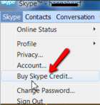

Call your friends and families on their landline and mobile phones!

With your Skype Credit, you can click on Call Phones  and enter the phone number of the party you want to call.  It is just like making a phone call from your landline phone, just much cheaper.  When you have Skype Credit , the Skype Credit indicator shows you how much money you have left on the credit. | 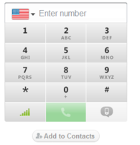

Questions for next time:
____________________________________________________________________________________________________________________________________________________________________________________________________________________________________________________________________________________________________________________________________________________________________________________________________________________________________

