Creating with Canva
Brianna Walker • Instruction & Technology Librarian • bwalker@vapld.info
Introduction
Canva is an easy to use online graphic design platform used for creating web graphics and printed media. It can be used to create professional quality materials – presentations, flyers, brochures, and more. Users can also create flyers, invitations and graphics for social media for personal use.
Getting Started
- Go to www.Canva.com.
- Choose Create your free account using an email address, Google or Facebook account.
- Enter a name, email and password to set up an account.
- You will be sent an email confirming your account.
- Click on Confirm my account.
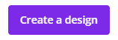
Beginning a Design
Click on Create a Design to begin. Choose your design format by clicking on the appropriate icon. There are many options, including posters, social media posts, cards, and slideshows.
You can also customize your project by choosing the Custom Dimensions button at the top. Choose from px for pixel size; mm for millimeters or in for inches, and enter your dimensions into the Width and Height fields.
Once you choose a design type, you’ll be entered into the Canva editor, where you can create your design.
Designing with Templates
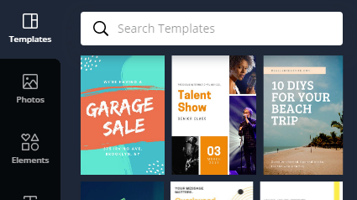
Layout templates are a great way to get started because they can be easily modified to suit the needs of your project.
- From the editor, click on the Templates Tab and select a template. It will open automatically in your workspace.
- If a template is free, a free button will appear in the bottom-right corner when you hover over the image.

Layouts can be customized by changing the background, text color, text size, and font.
To change the background color:
- Click on an area that has no other elements.
- A box will appear in the white bar at the top of the editor (to the left). It will be the same color as the background. Click on it.
- You can choose a color from the palette that appears, or use a custom color.
To use a custom color:
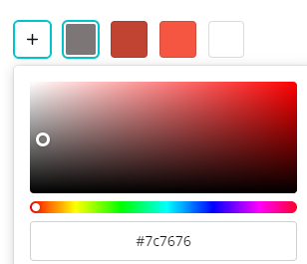
- Click on the palette button to open the color picker
- To pick a color, slide the circle on the rainbow bar to the right or left.
- If you have a hex code, type it in the box
- Use the gray scale slider to change the shade
- Click outside of the color picker to close it
If you choose not to use a Canva layout, a blank white space will appear in your workspace. You can begin to add your design elements. Follow the steps above to add backgrounds.
Editing Text
Canva allows you to modify existing text, or add your own
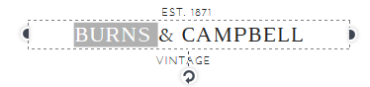
To modify existing text:
- Click on the text
- Highlight the text you want to delete and type over it.
When you click on the text, some options will appear on the top. You can change the font, size of text, color, make the text Bold or Italic, change the alignment, and add bullets or numbers.
The Spacing button allows you to change the spacing between letters and lines. Use the slider to adjust either.
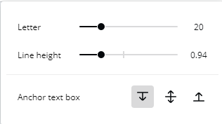

Bulleted Lists
Font size
Color
Alignment
Font

Adding Text
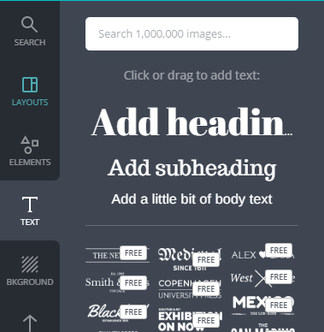
- Select the Text Tab on the left sidebar
- Pick a text type to add. You can choose a generic heading/subheading/body, or a pre-set combination. To add the text, click on it.
- To move your text, click on it. When light blue lines appear, you can click & drag it into position.
- The text box can also be positioned at an angle by clicking on it, then grabbing the circle (at the bottom of the box) and turning.
- To delete a text box, click on it and press delete.
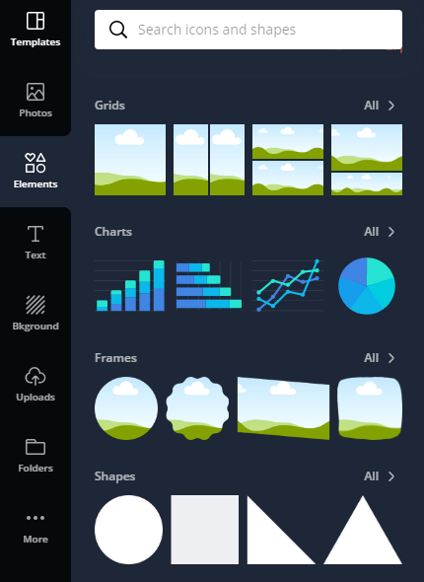
Elements
Canva provides Elements – pre-made graphics that you can add to your project. Some are free, others cost $1. There are many types of elements, including Frames, Shapes, Gradients, Stickers, Lines, and Icons.
Elements are searchable: type a keyword into the search box to find an image.
To add an Element image to your work, click on the element and use the arrow icons to position the it on the page.
To delete it, select the Element and press delete.
Adding Photos
Canva has pre-loaded photos that you use on your cards. To add one,
- Click on the Photos icon in the sidebar
- Search for the subject in the search box
- Click on the photo to add it to your design.
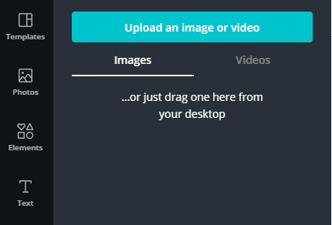
Uploading photos
Canva allows you to upload your own photos for personalized designs.
- Go to the Uploads tab.
- Click the Upload an image button, or drag an image from your desktop.
- Select a file to upload. Canva supports uploading images in JPEG, PNG, and SVG formats. Uploaded files be less than 25mb.
- Click Open to add it to you design.
Note: You can also drag and drop the image into Canva from your desktop or a folder.
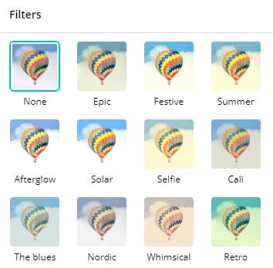
Filters
Filters can be added to any image. To use a Filter:
- Click on the image to which you would like to apply the filter.
- Click Filter on the top toolbar.
- Click on the filter to apply it to the photo.
- Once you select a filter, you can adjust the intensity with the sliding bar.
- To remove a filter, click the first button: None.
Cropping Photos
To crop a photo :
- Select the image and press the Crop button in the top toolbar.
- Grab an edge and move it inward to resize the image.
- Grab the image itself to move it around within the crop
Note: If you want to keep the aspect ratio, double click on the photo and drag from a corner.
Designing with Grids
Grids are pre-set layouts that you can add from the Elements Tab. They are useful if you are working with multiple pictures, because you can crop and edit each one individually. To add a Grid:
- Click on the desired grid to add it to your workspace
- The space between your grid boxes can be adjusted using the Spacing button
- Use the slider to increase or decrease the margins
Editing a Grid Box
To change the background color of a grid square:
- Click on the individual box or section.
- Click on the Color Tab.
- To add text or an element, drag and drop it into place.

To Add an Image to a Grid:
- Go to the Photos or Uploads tab and find the image you want
- Click and drag it over the grid where you want to place it
- To move it around, double click
Adding or Deleting a Page
- Click on +Add a new page at the bottom of the editor or you can click on the duplicate or copy a page button.
- To delete a page, click on the Trash bin icon at the right-hand side of your design. If you've accidentally deleted a page, don't worry! You can always Undo this deletion.
Note: If you accidentally deleted a page, just click the Undo button at the top of the page (or press Ctrl + Z)
Rearranging Page Order
You can also rearrange the order of the pages according to its proper sequence. There are two ways to change the order of the page:
Click on the move arrows located above the page in a design to move a page up or down.
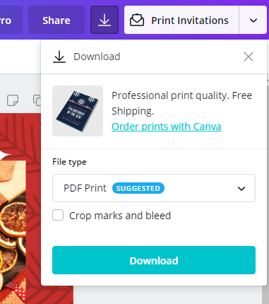
Or click and drag the page number to the right of the page to its new position.

Downloading Your Design
Publish and download your design. Click the Download button in the upper right-hand corner of the editor.
Change the file type by clicking on the drop-down menu. You have the option to download your designs as JPEG, PNG, PDF, Video, or GIF. Video and GIF are better suited to multi-page presentations.
Additional Resources
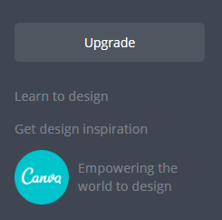
LinkedIn Learning (formerly Lynda.com) offers over 100,000 courses at all skill levels covering everything from computer programming languages to design software. Courses are taught by experienced and knowledgeable industry professionals through videos. Students have access to class files and transcripts of the lesson so they can follow along. Access LinkedInLearning.com with your library card number by visiting www.vapld.info 🡪 Research 🡪 Online Research & Learning 🡪LinkedIn Learning
Book an individual help session for 45 minutes with a librarian by calling (847) 634-3650.
Graphic Design books can be found on the following shelf: 741.6
Canva has excellent tutorials and step by step guides including a design school.
Go to https://designschool.canva.com/tutorials/
Works Consulted: Canva https://designschool.canva.com/tutorials/
Resources for free photographs
https://creativecommons.org/
https://stocksnap.io/
https://stock.tookapic.com/photos?filter=free
http://picography.co/
http://mmtstock.com/
http://kaboompics.com/
http://epicantus.tumblr.com/
http://jeshoots.com/
http://pixabay.com/
http://cupcake.nilssonlee.se/
http://www.uhdwallpapers.org/
http://kaboompics.com/
http://foodiesfeed.com/
http://www.raumrot.com/10/
https://unsplash.com/
http://www.gratisography.com/
http://negativespace.co/
http://www.lifeofpix.com/
http://deathtothestockphoto.com/
http://cargocollective.com/
https://picjumbo.com/
http://www.imcreator.com/free
http://nos.twnsnd.co/
http://getrefe.tumblr.com/
http://freestocks.org/
http://snapwiresnaps.tumblr.com/
http://jaymantri.com/

